**Note**: Consider the following before starting the assignment:

* A **static field** declared inside a class is called a **class-level variable**. To access this variable, use the class name and the dot operator (e.g., Integer.MAX_VALUE).
* A **static method** defined inside a class is called a **class-level method**. To access this method, use the class name and the dot operator (e.g., Integer.parseInt()).
* When accessing static members within the same class, you do not need to use the class name.

#### ****1. Working with**** java.lang.Boolean

**a.** Explore the [Java API documentation for java.lang.Boolean](https://docs.oracle.com/javase/8/docs/api/java/lang/Boolean.html) and observe its modifiers and super types.

**b.** Declare a method-local variable status of type boolean with the value true and convert it to a String using the toString method. (Hint: Use Boolean.toString(Boolean) ).

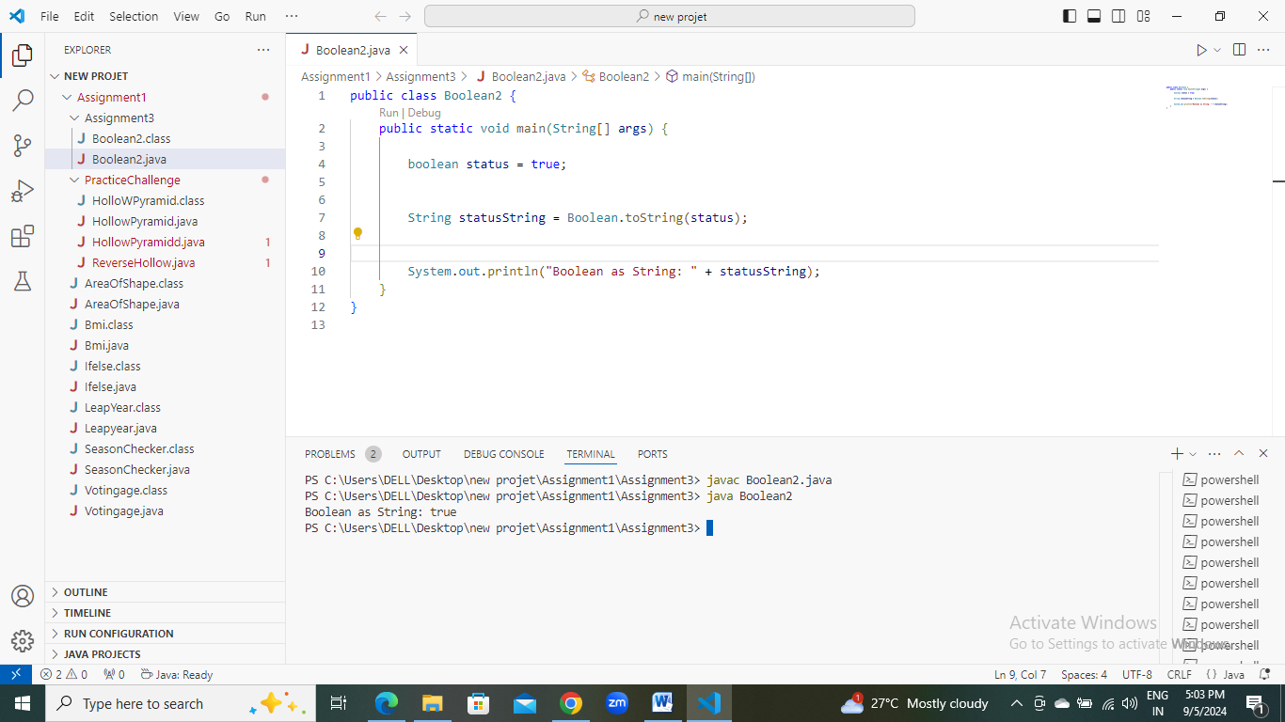

**c.** Declare a method-local variable strStatus of type String with the value "true" and convert it to a boolean using the parseBoolean method. (Hint: Use Boolean.parseBoolean(String)).

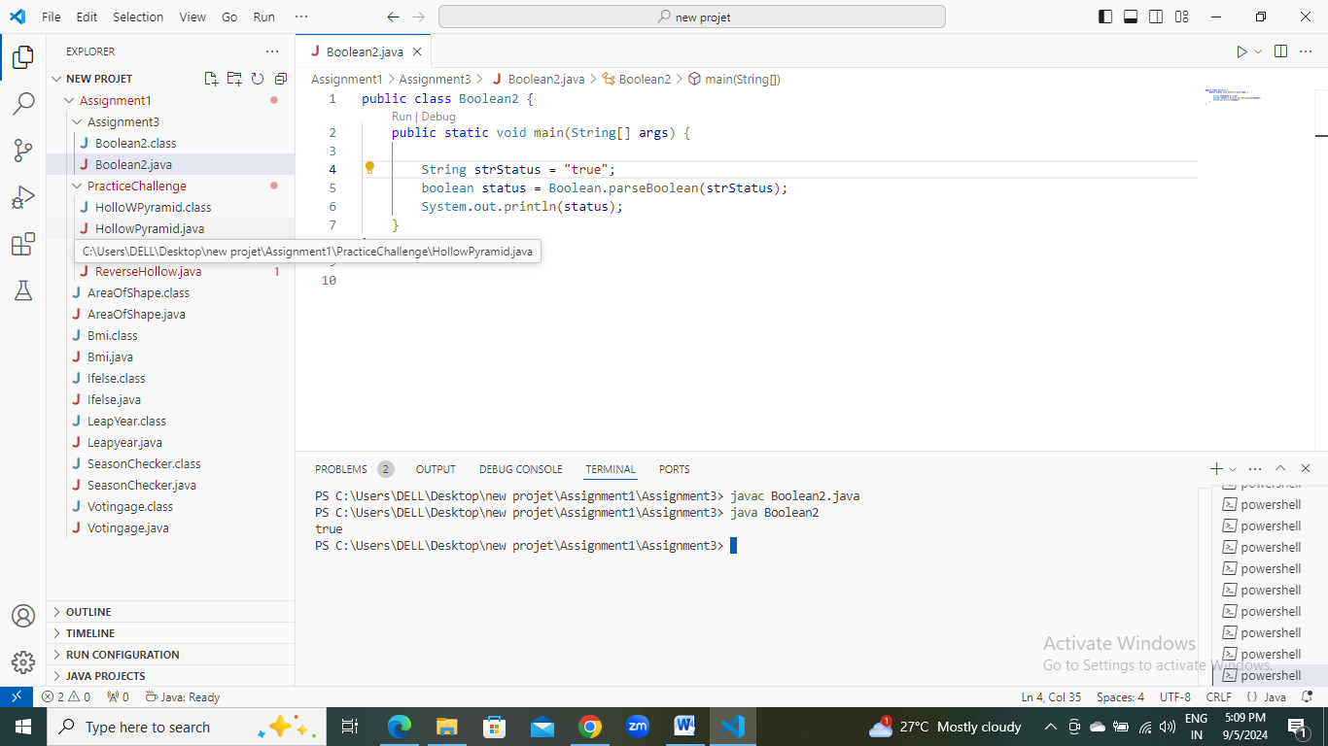

**d.** Declare a method-local variable strStatus of type String with the value "1" or "0" and attempt to convert it to a boolean. (Hint: parseBoolean method will not work as expected with "1" or "0").

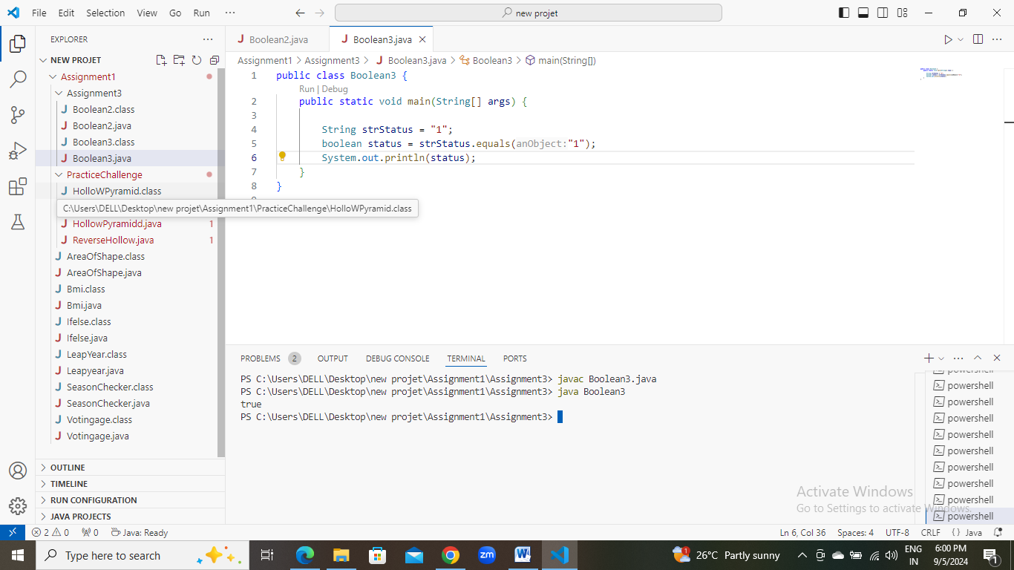

**e.** Declare a method-local variable status of type boolean with the value true and convert it to the corresponding wrapper class using Boolean.valueOf(). (Hint: Use Boolean.valueOf(boolean)).

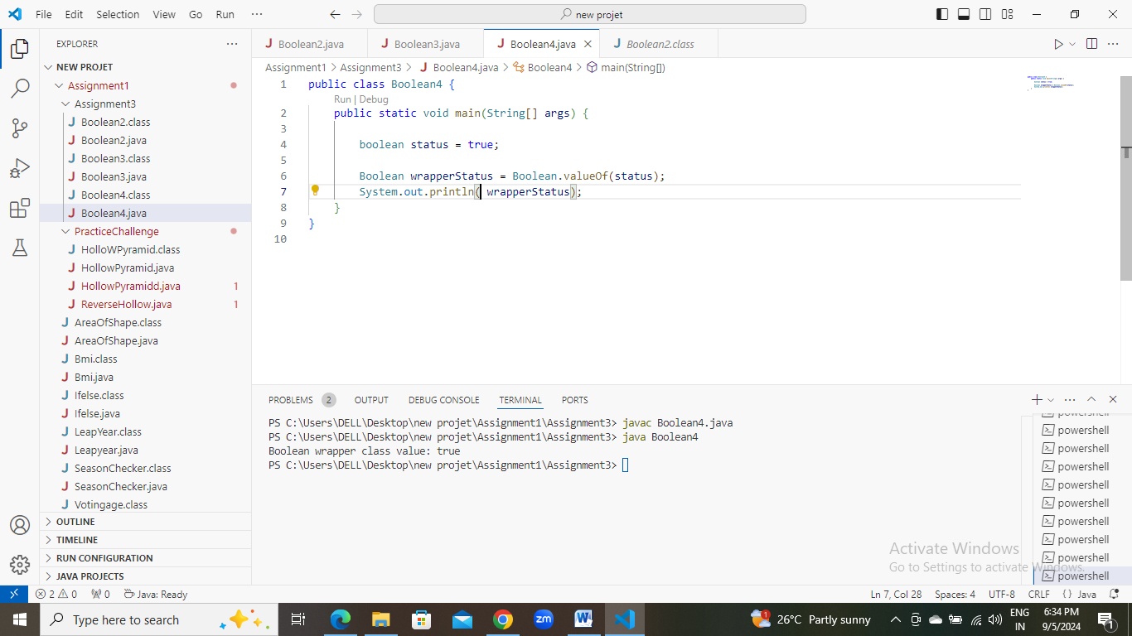

**f.** Declare a method-local variable strStatus of type String with the value "true" and convert it to the corresponding wrapper class using Boolean.valueOf(). (Hint: Use Boolean.valueOf(String)).

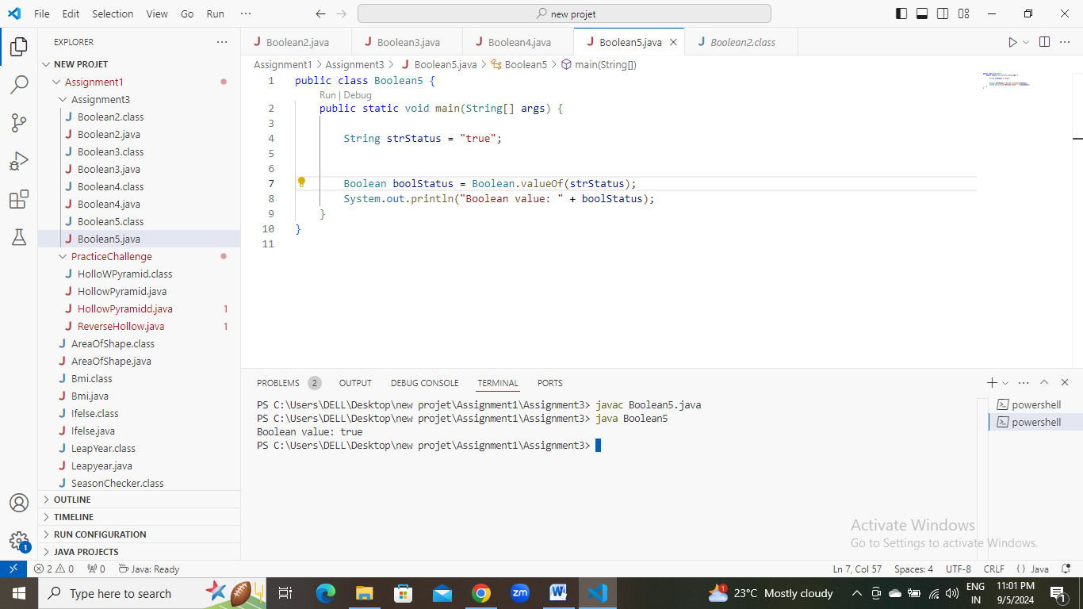

**g.** Experiment with converting a boolean value into other primitive types or vice versa and observe the results.

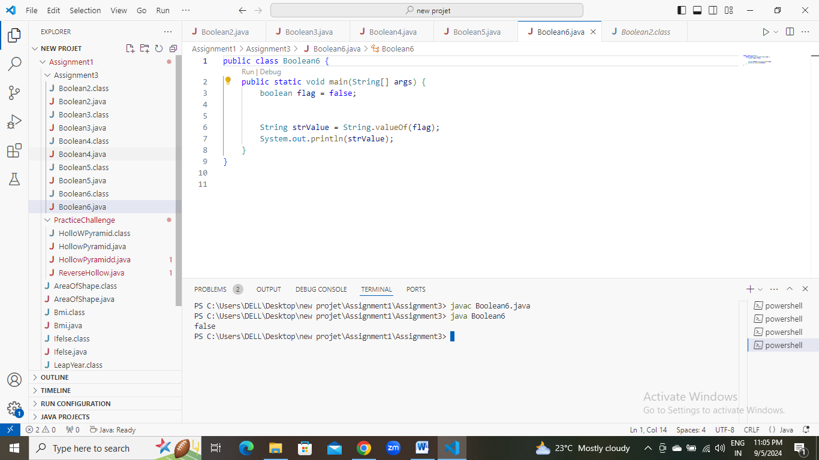

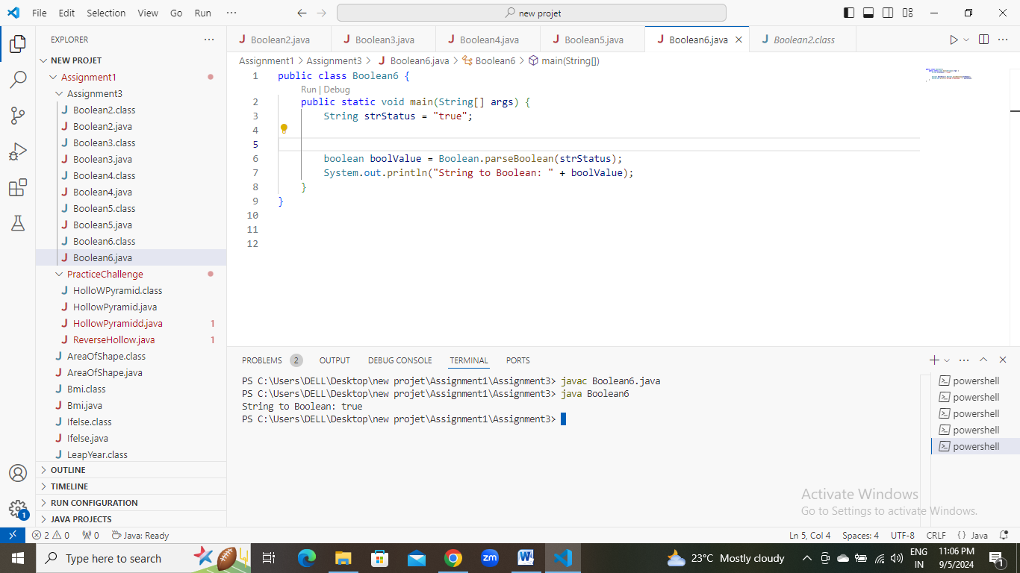

#### ****2. Working with**** java.lang.Byte

**a.** Explore the [Java API documentation for java.lang.Byte](https://docs.oracle.com/javase/8/docs/api/java/lang/Byte.html) and observe its modifiers and super types.

**b.** Write a program to test how many bytes are used to represent a byte value using the BYTES field. (Hint: Use Byte.BYTES).

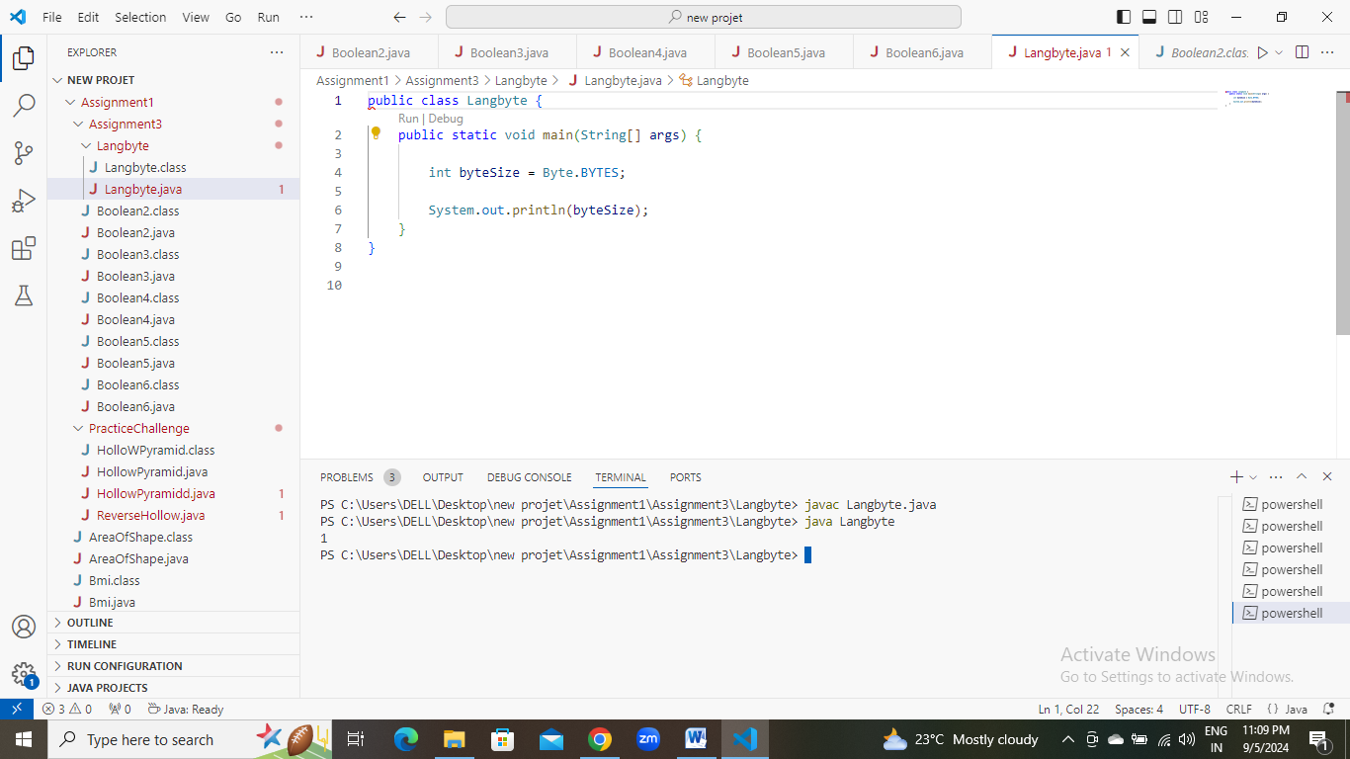

**c.** Write a program to find the minimum and maximum values of byte using the MIN_VALUE and MAX_VALUE fields. (Hint: Use Byte.MIN_VALUE and Byte.MAX_VALUE).

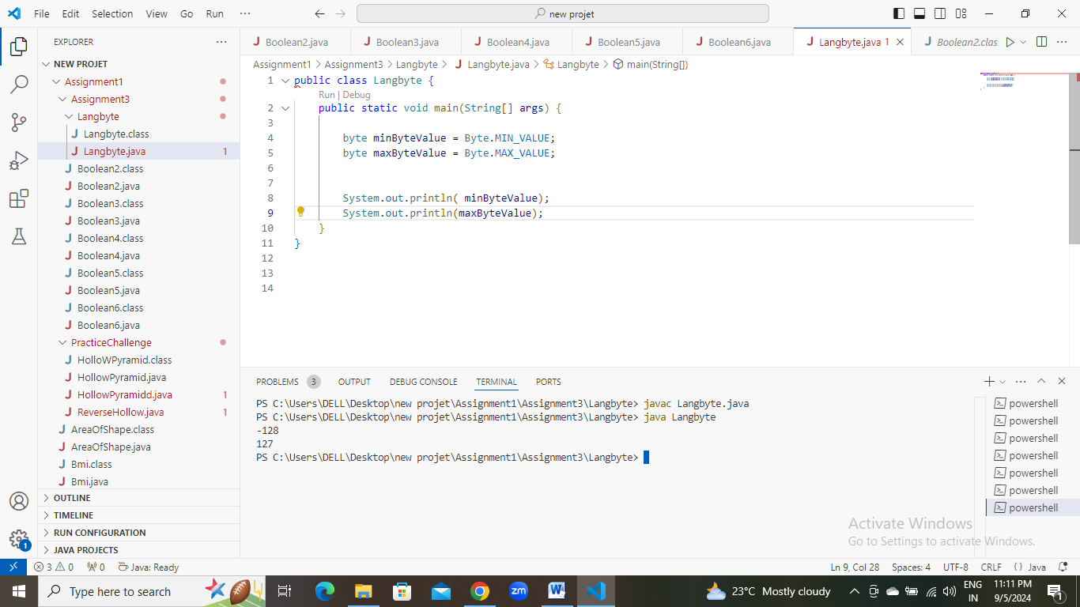

**d.** Declare a method-local variable number of type byte with some value and convert it to a String using the toString method. (Hint: Use Byte.toString(byte)).

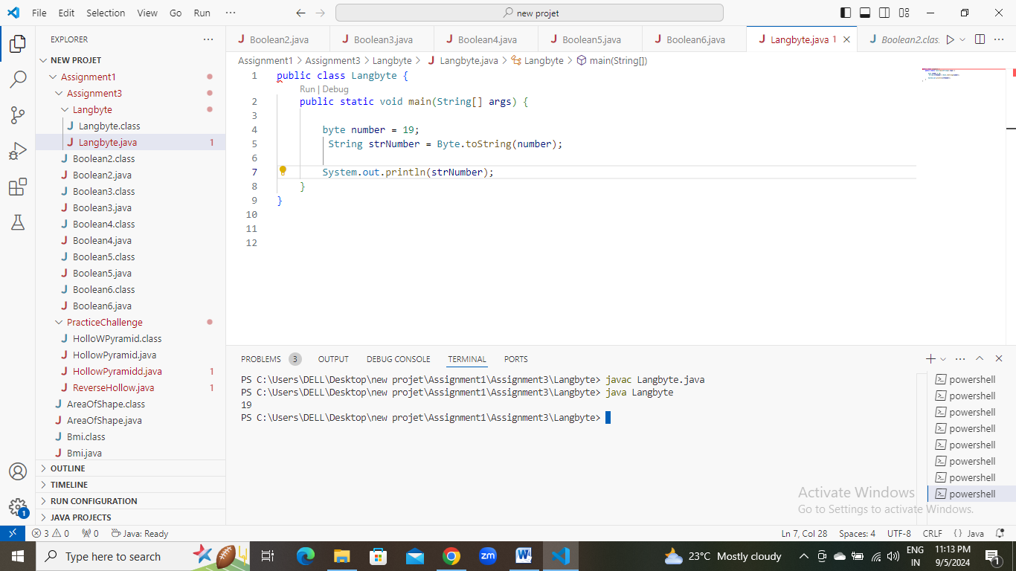

**e.** Declare a method-local variable strNumber of type String with some value and convert it to a byte value using the parseByte method. (Hint: Use Byte.parseByte(String)).

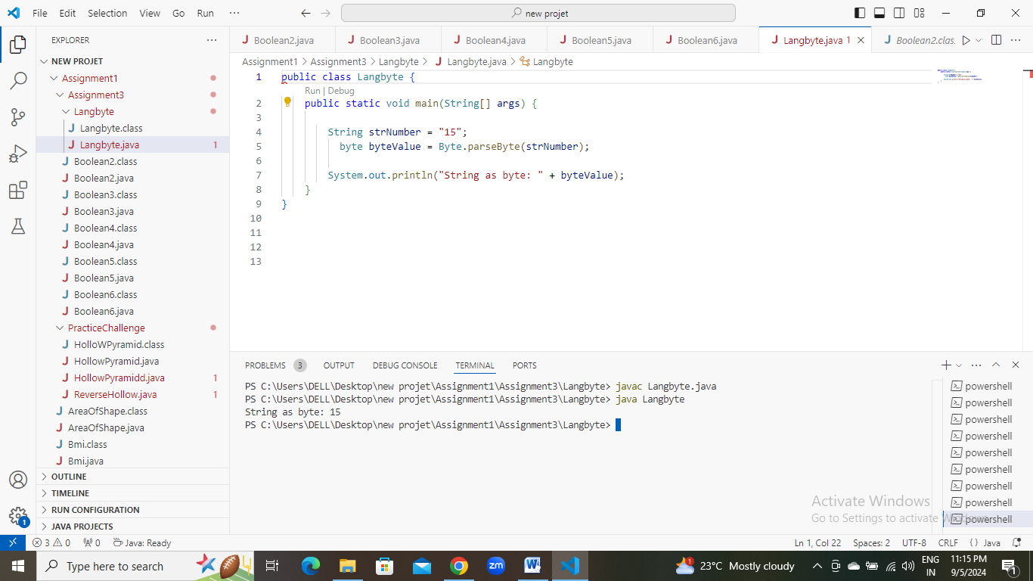

**f.** Declare a method-local variable strNumber of type String with the value "Ab12Cd3" and attempt to convert it to a byte value. (Hint: parseByte method will throw a NumberFormatException).

**g.** Declare a method-local variable number of type byte with some value and convert it to the corresponding wrapper class using Byte.valueOf(). (Hint: Use Byte.valueOf(byte)).

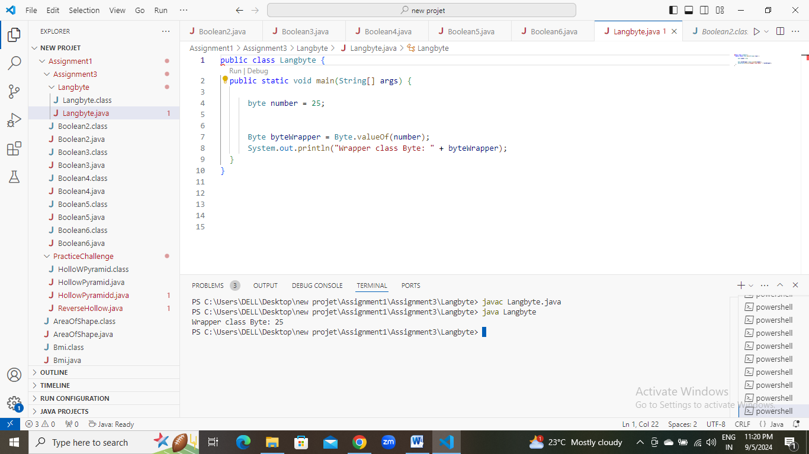

**h.** Declare a method-local variable strNumber of type String with some byte value and convert it to the corresponding wrapper class using Byte.valueOf(). (Hint: Use Byte.valueOf(String)).

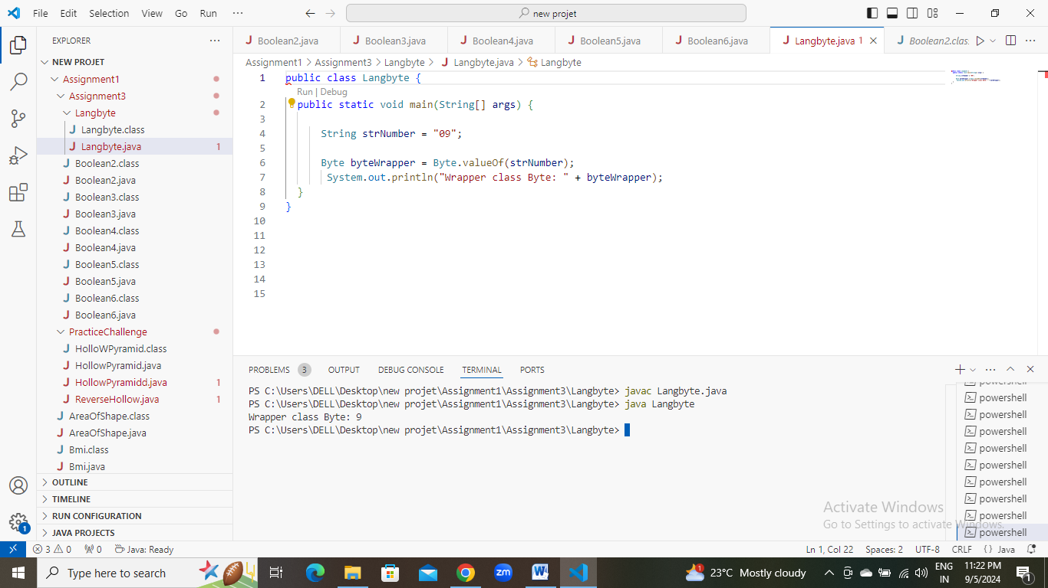

1. Experiment with converting a byte value into other primitive types or vice versa and observe the results.
2. 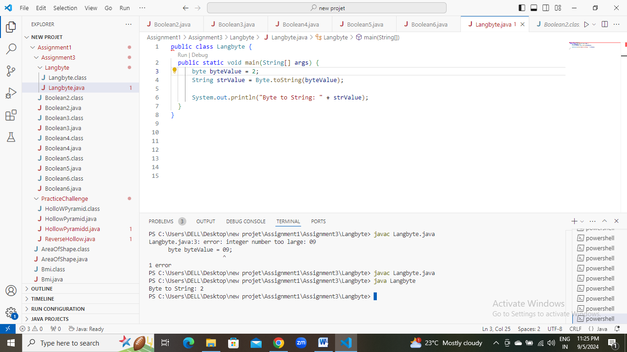

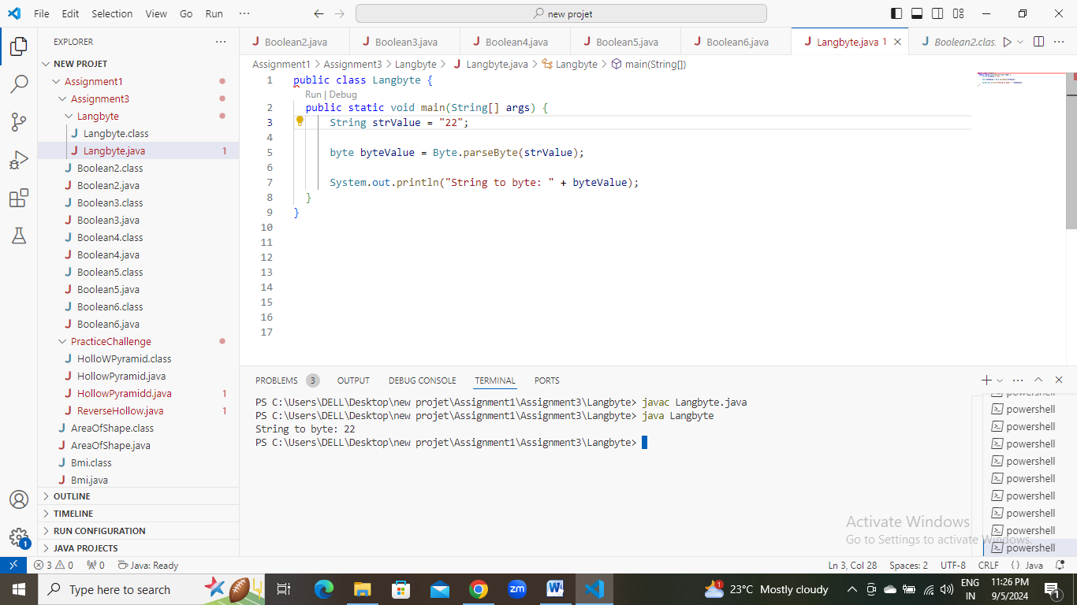

#### ****3. Working with**** java.lang.Short

**a.** Explore the [Java API documentation for java.lang.Short](https://docs.oracle.com/javase/8/docs/api/java/lang/Short.html) and observe its modifiers and super types.

**b.** Write a program to test how many bytes are used to represent a short value using the BYTES field. (Hint: Use Short.BYTES).

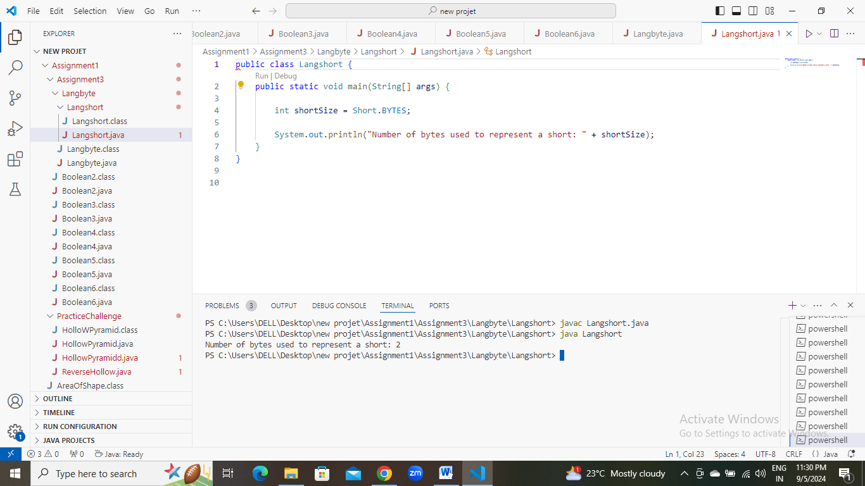

**c.** Write a program to find the minimum and maximum values of short using the MIN_VALUE and MAX_VALUE fields. (Hint: Use Short.MIN_VALUE and Short.MAX_VALUE).

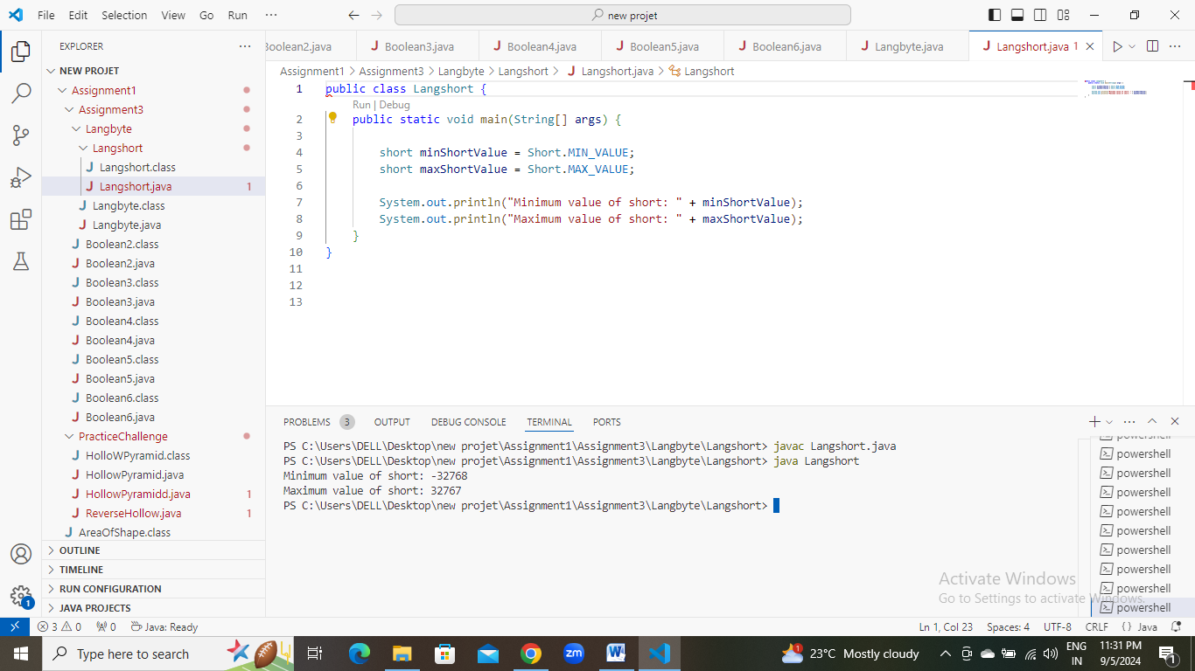

**d.** Declare a method-local variable number of type short with some value and convert it to a String using the toString method. (Hint: Use Short.toString(short)).

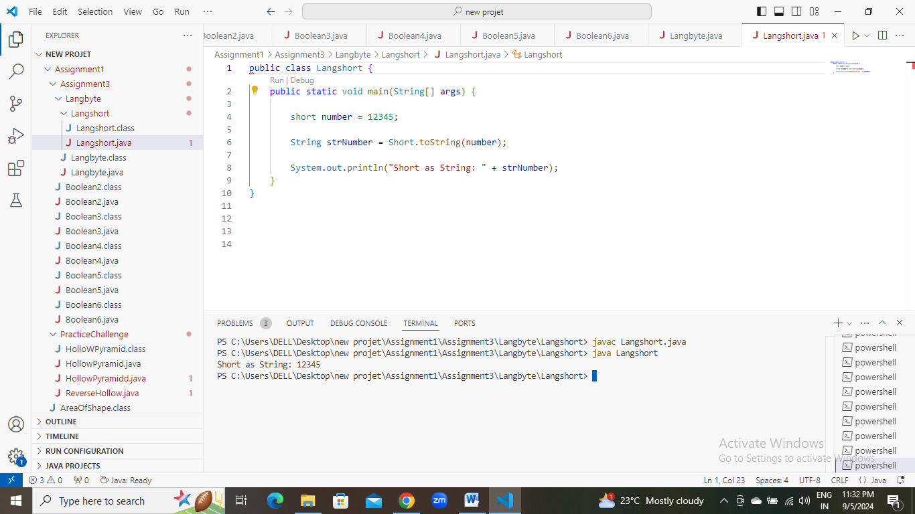

**e.** Declare a method-local variable strNumber of type String with some value and convert it to a short value using the parseShort method. (Hint: Use Short.parseShort(String)).

**f.** Declare a method-local variable strNumber of type String with the value "Ab12Cd3" and attempt to convert it to a short value. (Hint: parseShort method will throw a NumberFormatException).

**g.** Declare a method-local variable number of type short with some value and convert it to the corresponding wrapper class using Short.valueOf(). (Hint: Use Short.valueOf(short)).

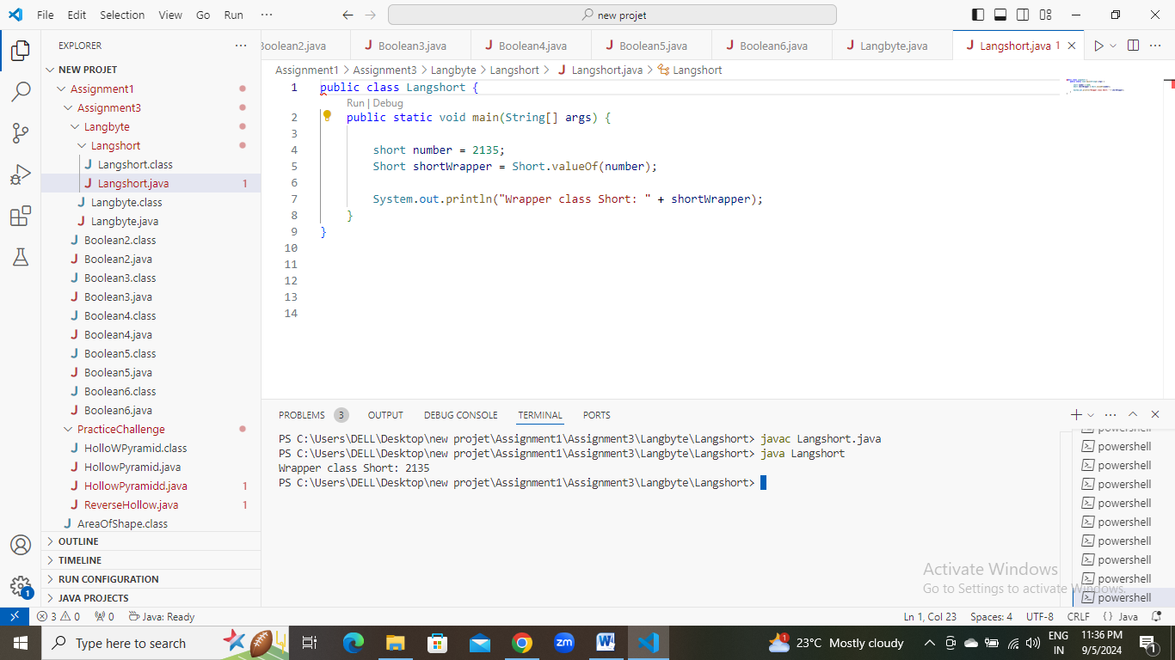

**h.** Declare a method-local variable strNumber of type String with some short value and convert it to the corresponding wrapper class using Short.valueOf(). (Hint: Use Short.valueOf(String)).

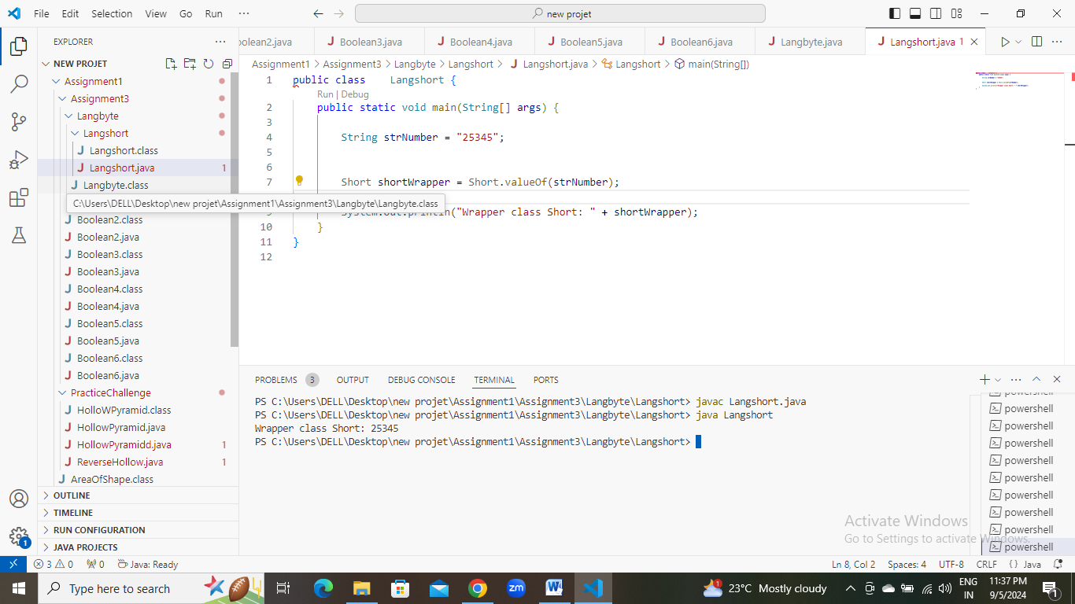

1. Experiment with converting a short value into other primitive types or vice versa and observe the results.
2. 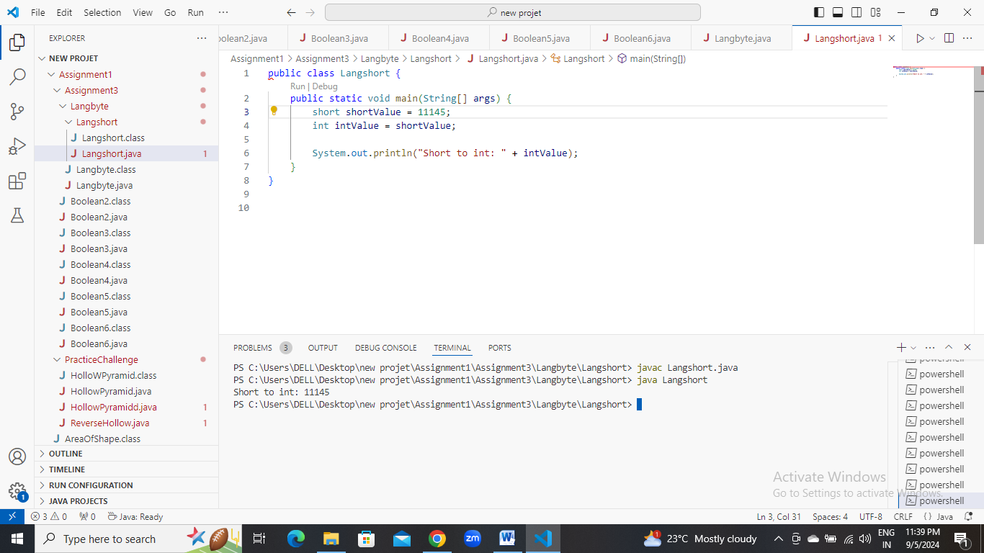
3. 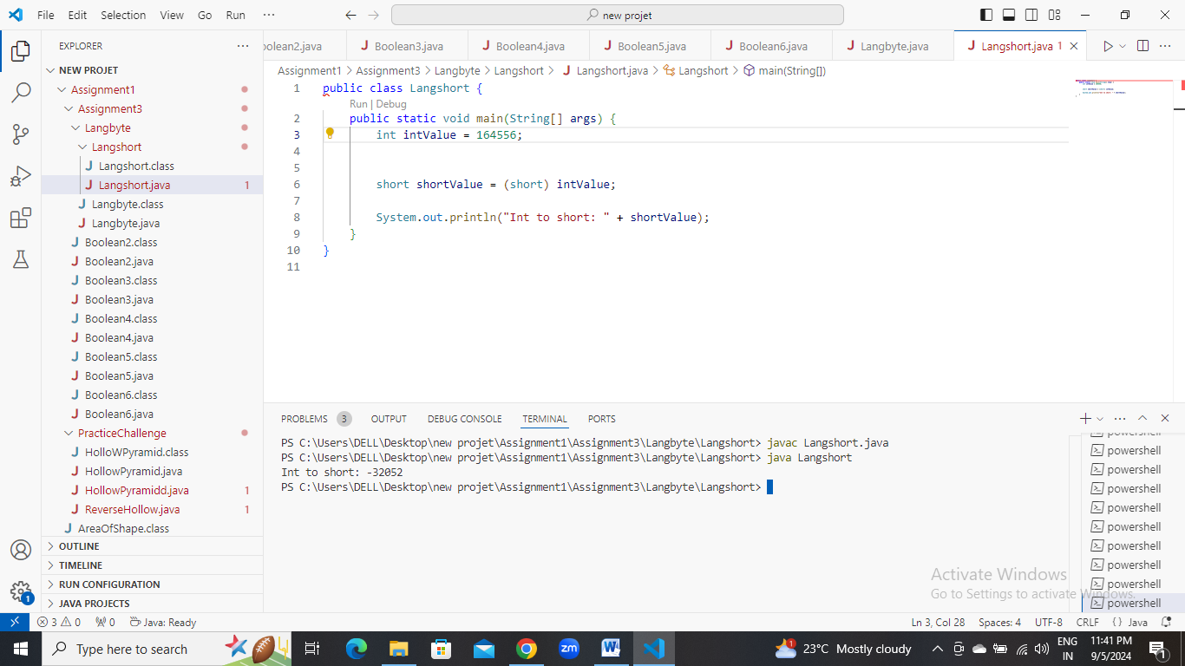

#### ****4. Working with**** java.lang.Integer

**a.** Explore the [Java API documentation for java.lang.Integer](https://docs.oracle.com/javase/8/docs/api/java/lang/Integer.html) and observe its modifiers and super types.

**b.** Write a program to test how many bytes are used to represent an int value using the BYTES field. (Hint: Use Integer.BYTES).

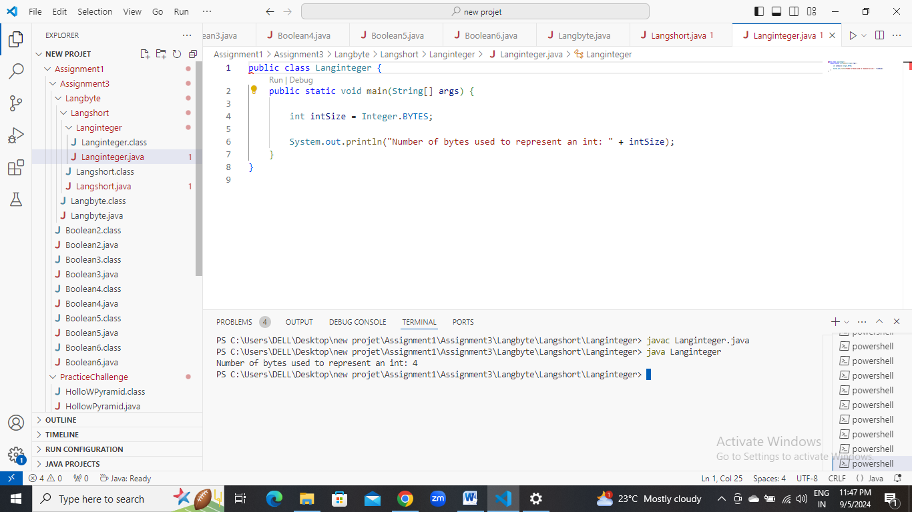

**c.** Write a program to find the minimum and maximum values of int using the MIN_VALUE and MAX_VALUE fields. (Hint: Use Integer.MIN_VALUE and Integer.MAX_VALUE).

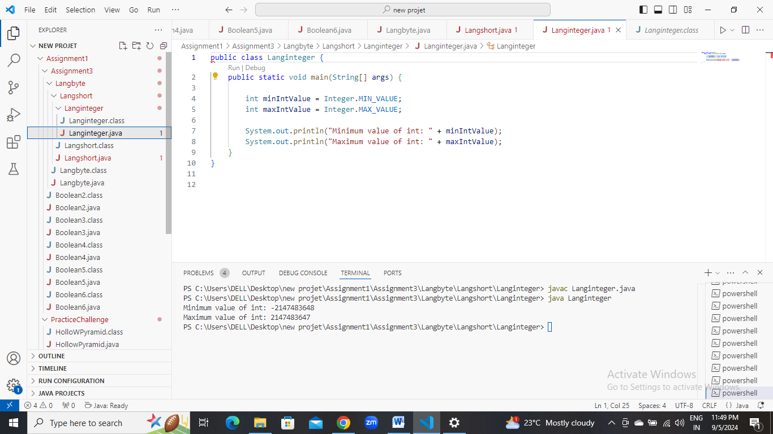

**d.** Declare a method-local variable number of type int with some value and convert it to a String using the toString method. (Hint: Use Integer.toString(int)).

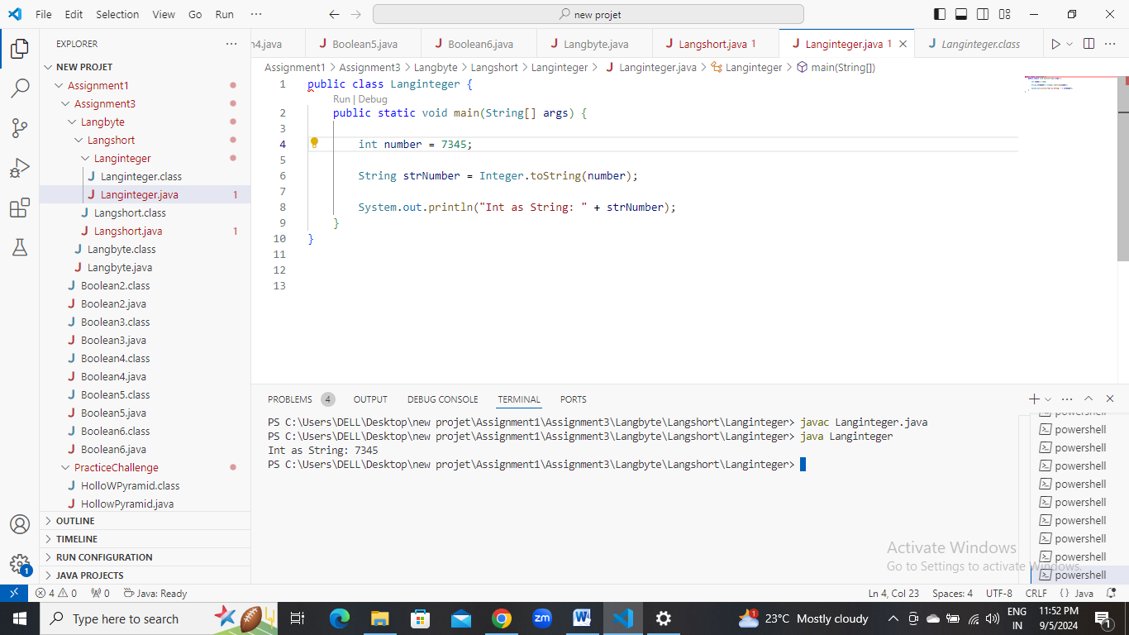

**e.** Declare a method-local variable strNumber of type String with some value and convert it to an int value using the parseInt method. (Hint: Use Integer.parseInt(String)).

**f.** Declare a method-local variable strNumber of type String with the value "Ab12Cd3" and attempt to convert it to an int value. (Hint: parseInt method will throw a NumberFormatException).

**g.** Declare a method-local variable number of type int with some value and convert it to the corresponding wrapper class using Integer.valueOf(). (Hint: Use Integer.valueOf(int)).

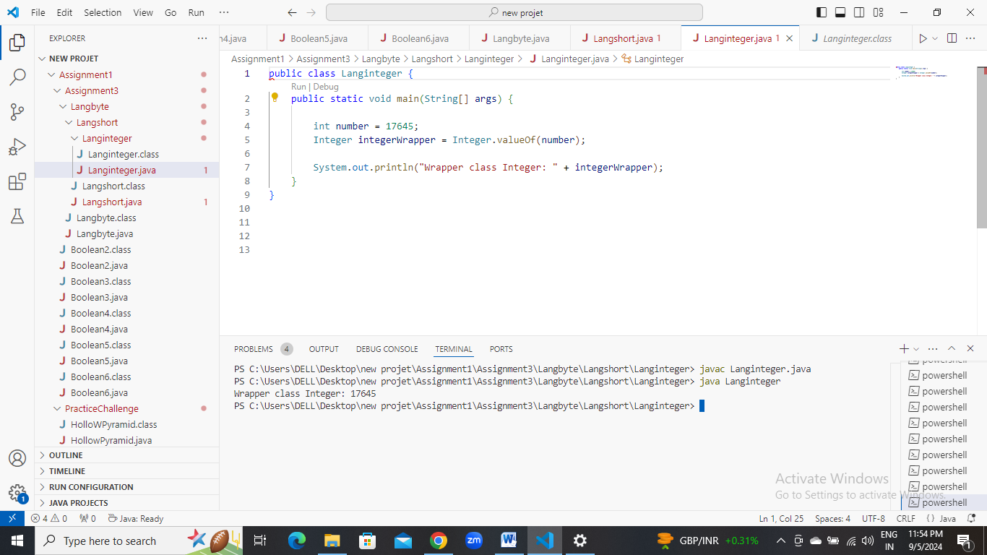

**h.** Declare a method-local variable strNumber of type String with some integer value and convert it to the corresponding wrapper class using Integer.valueOf(). (Hint: Use Integer.valueOf(String)).

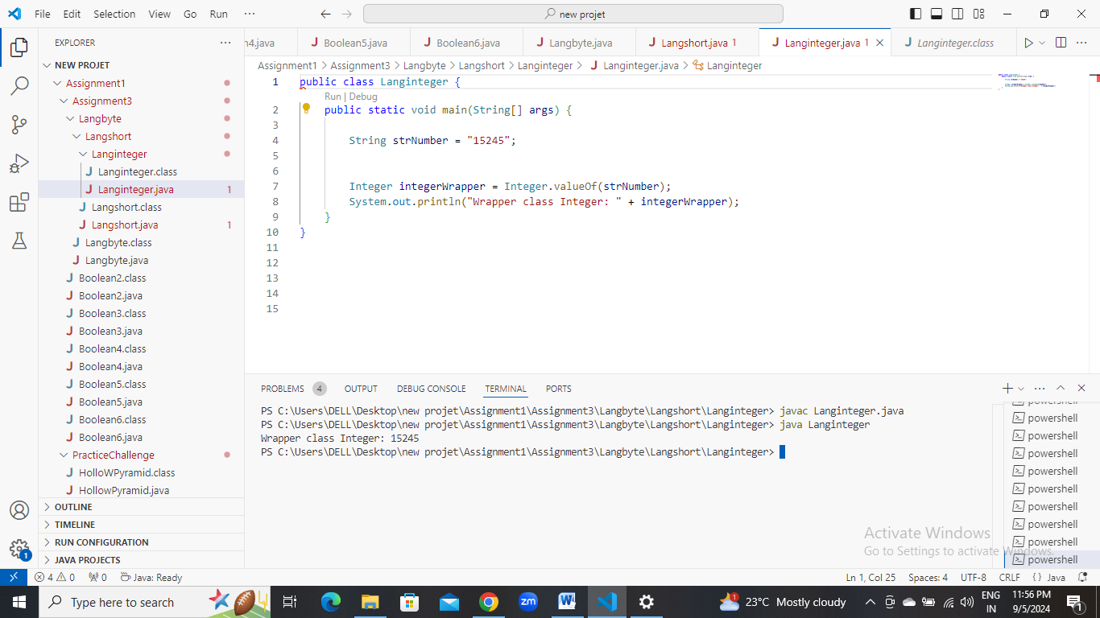

1. Declare two integer variables with values 10 and 20, and add them using a method from the Integer class. (Hint: Use Integer.sum(int, int)).
2. 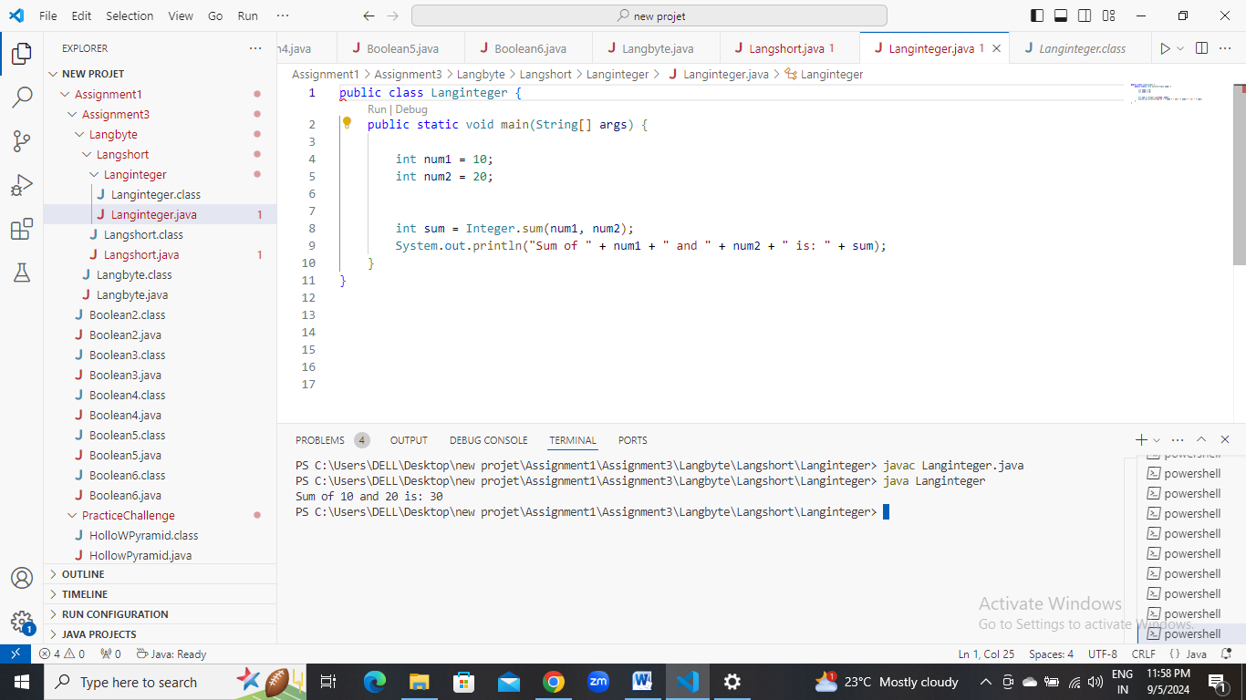

**j.** Declare two integer variables with values 10 and 20, and find the minimum and maximum values using the Integer class. (Hint: Use Integer.min(int, int) and Integer.max(int, int)).

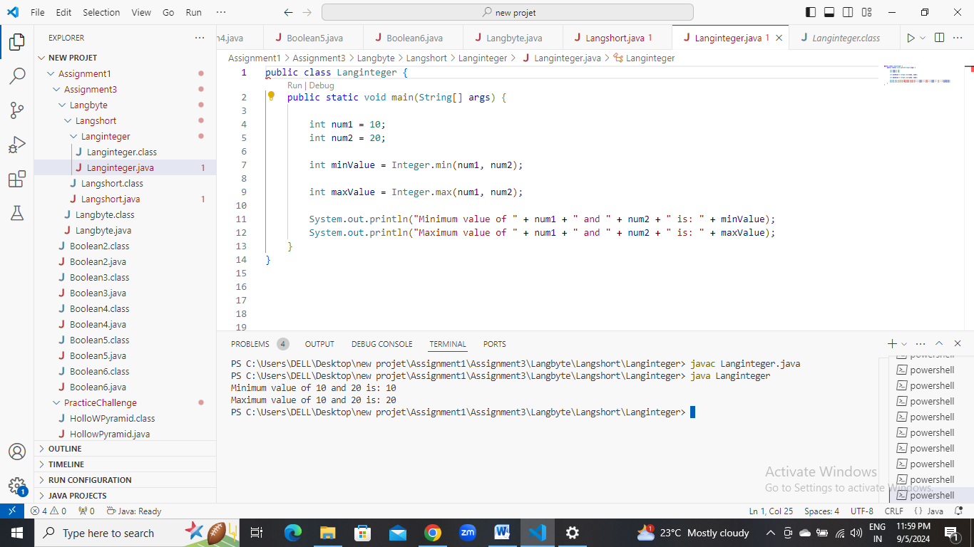

**k.** Declare an integer variable with the value 7. Convert it to binary, octal, and hexadecimal strings using methods from the Integer class. (Hint: Use Integer.toBinaryString(int), Integer.toOctalString(int), and Integer.toHexString(int)).

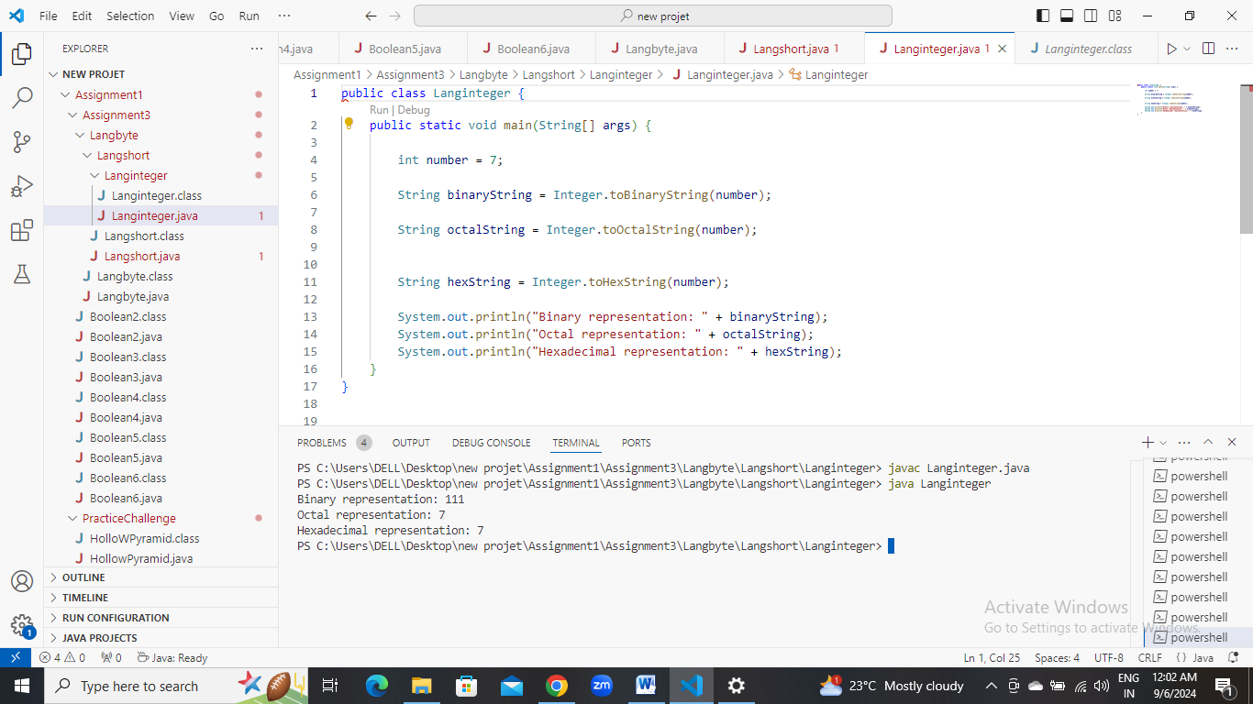

**l.** Experiment with converting an int value into other primitive types or vice versa and observe the results.

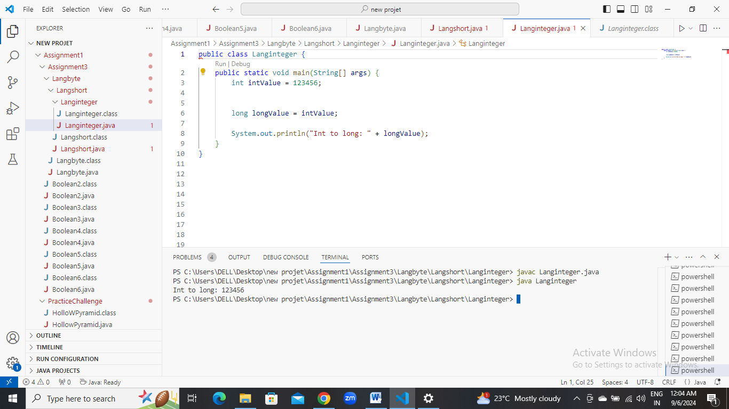

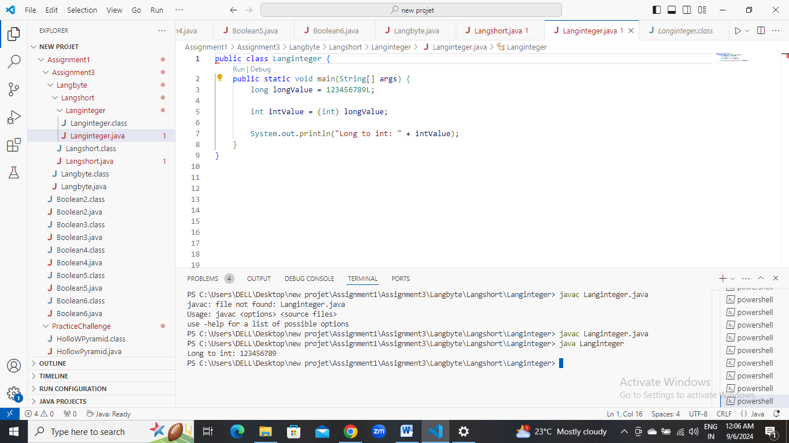

#### ****5. Working with**** java.lang.Long

**a.** Explore the [Java API documentation for java.lang.Long](https://docs.oracle.com/javase/8/docs/api/java/lang/Long.html) and observe its modifiers and super types.

**b.** Write a program to test how many bytes are used to represent a long value using the BYTES field. (Hint: Use Long.BYTES).

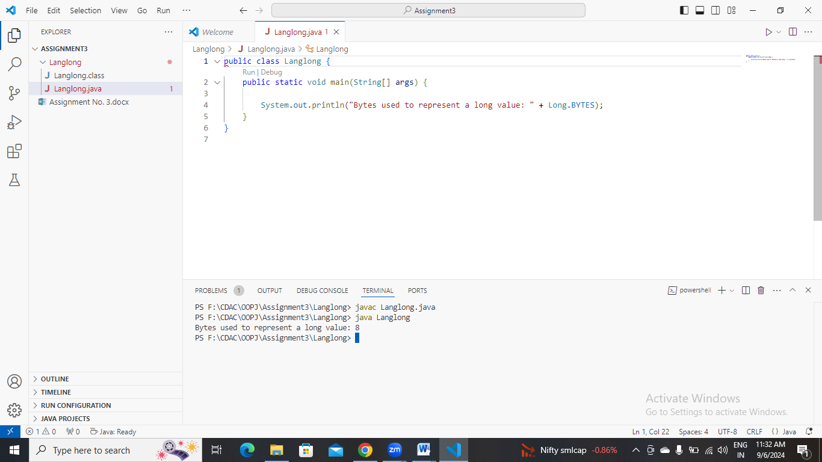

**c.** Write a program to find the minimum and maximum values of long using the MIN_VALUE and MAX_VALUE fields. (Hint: Use Long.MIN_VALUE and Long.MAX_VALUE).

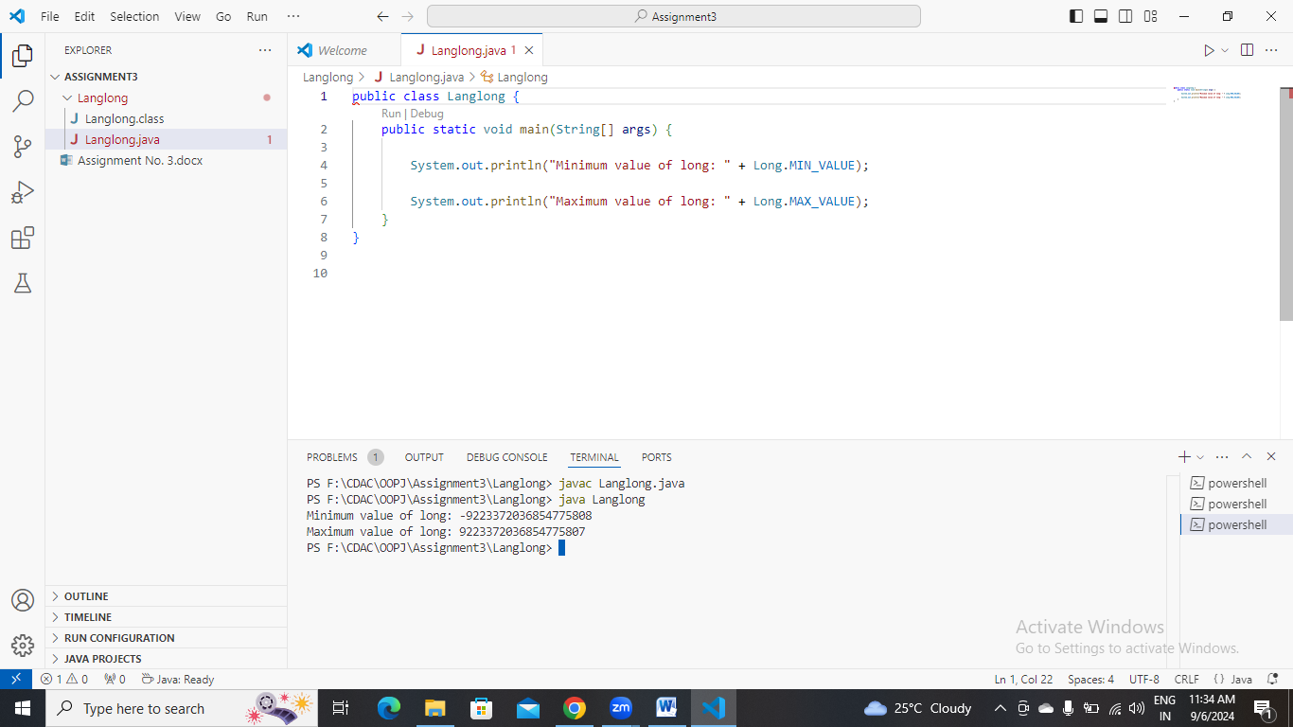

**d.** Declare a method-local variable number of type long with some value and convert it to a String using the toString method. (Hint: Use Long.toString(long)).

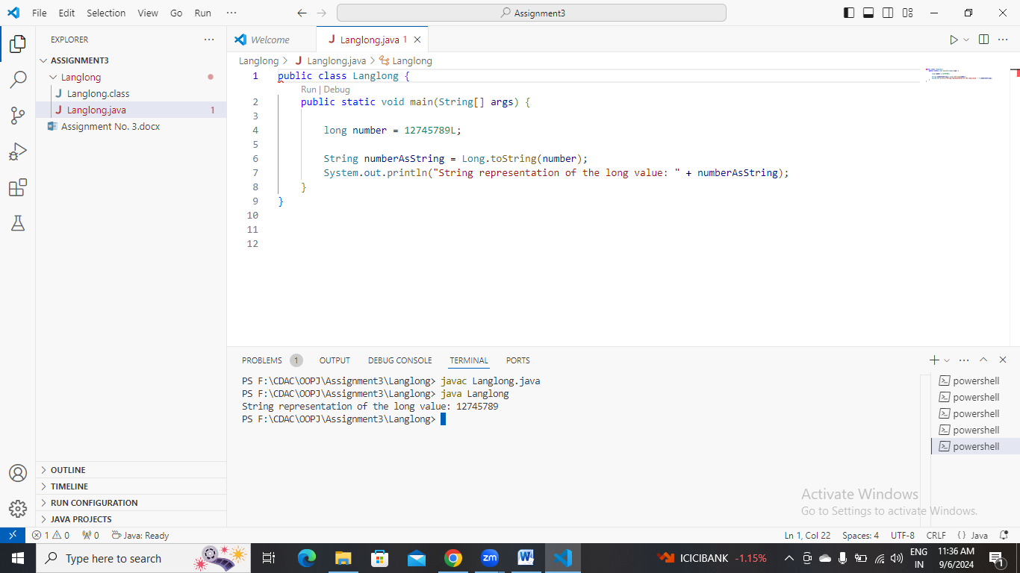

**e.** Declare a method-local variable strNumber of type String with some value and convert it to a long value using the parseLong method. (Hint: Use Long.parseLong(String)).

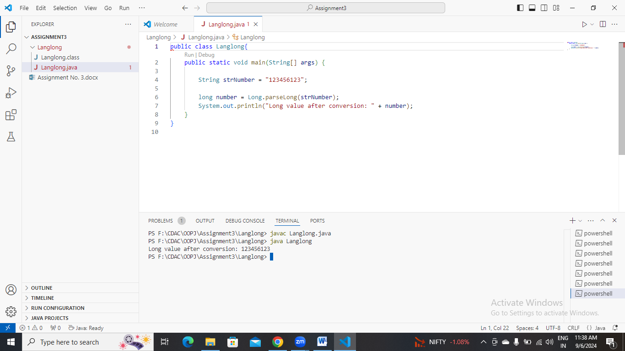

**f.** Declare a method-local variable strNumber of type String with the value "Ab12Cd3" and attempt to convert it to a long value. (Hint: parseLong method will throw a NumberFormatException).

**g.** Declare a method-local variable number of type long with some value and convert it to the corresponding wrapper class using Long.valueOf(). (Hint: Use Long.valueOf(long)).

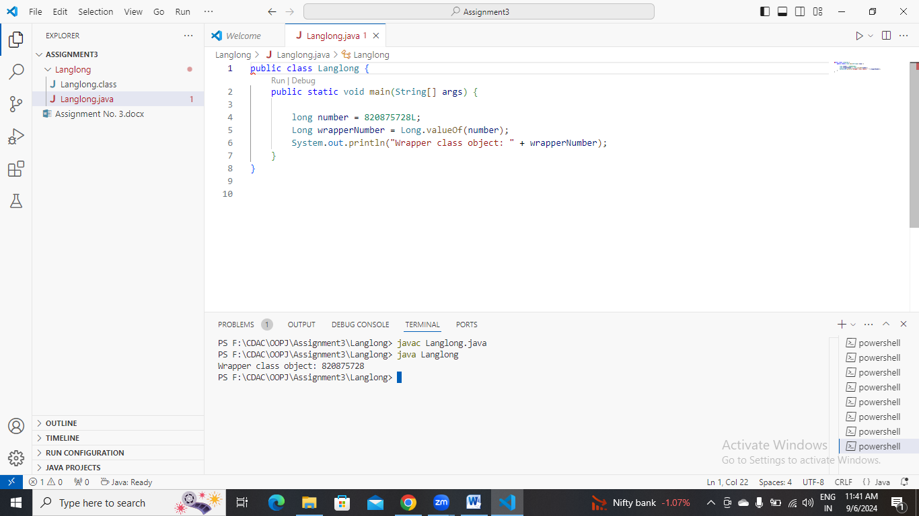

**h.** Declare a method-local variable strNumber of type String with some long value and convert it to the corresponding wrapper class using Long.valueOf(). (Hint: Use Long.valueOf(String)).

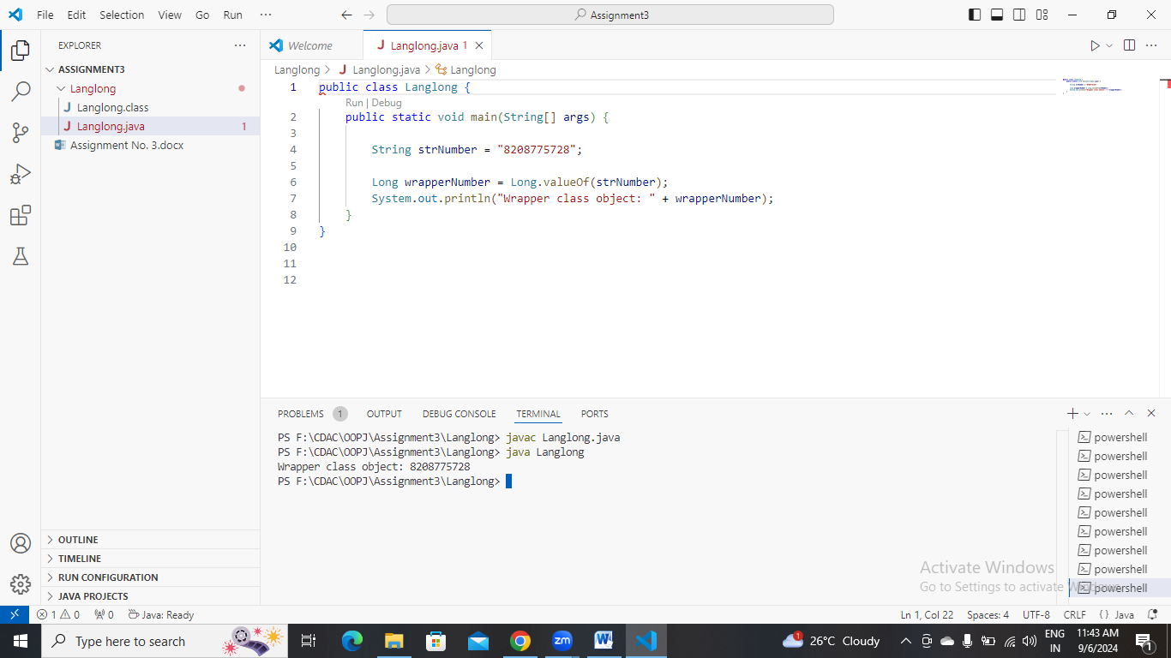

1. Declare two long variables with values 1123 and 9845, and add them using a method from the Long class. (Hint: Use Long.sum(long, long)).
2. 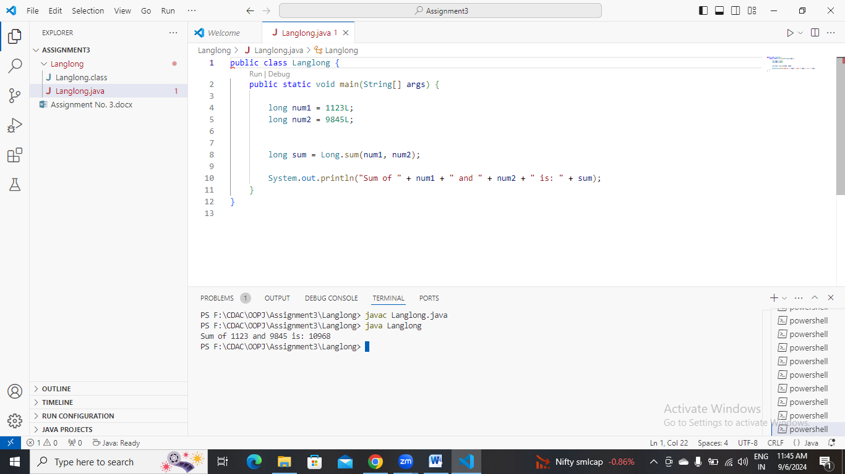

**j.** Declare two long variables with values 1122 and 5566, and find the minimum and maximum values using the Long class. (Hint: Use Long.min(long, long) and Long.max(long, long)).

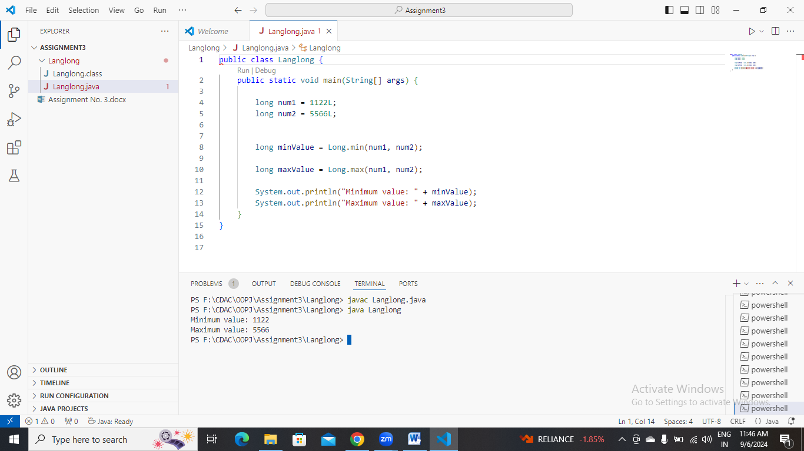

**k.** Declare a long variable with the value 7. Convert it to binary, octal, and hexadecimal strings using methods from the Long class. (Hint: Use Long.toBinaryString(long), Long.toOctalString(long), and Long.toHexString(long)).

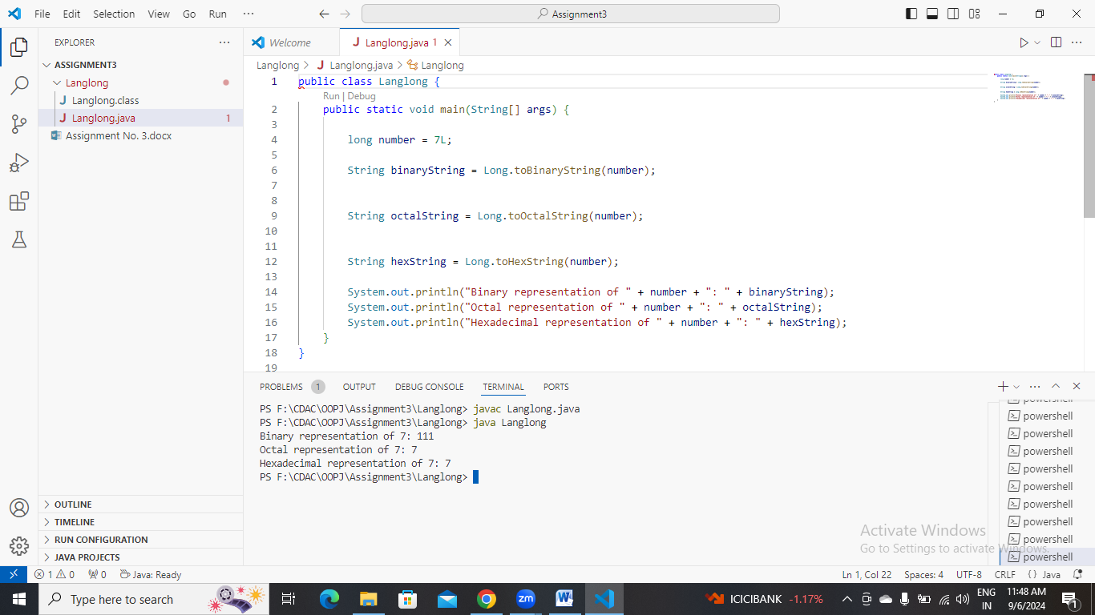

**l.** Experiment with converting a long value into other primitive types or vice versa and observe the results.

#### ****6. Working with**** java.lang.Float

**a.** Explore the [Java API documentation for java.lang.Float](https://docs.oracle.com/javase/8/docs/api/java/lang/Float.html) and observe its modifiers and super types.

**b.** Write a program to test how many bytes are used to represent a float value using the BYTES field. (Hint: Use Float.BYTES).

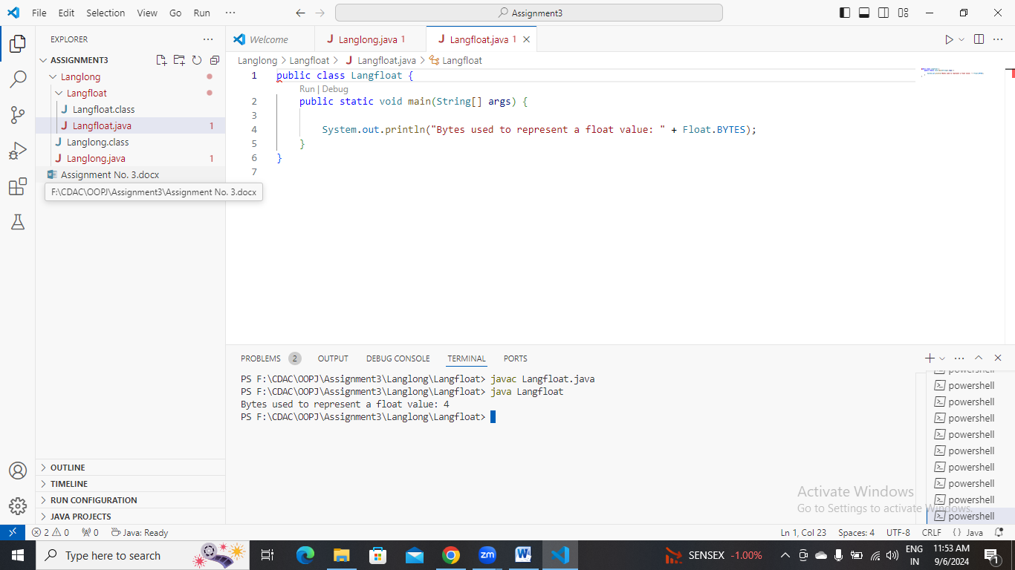

**c.** Write a program to find the minimum and maximum values of float using the MIN_VALUE and MAX_VALUE fields. (Hint: Use Float.MIN_VALUE and Float.MAX_VALUE).

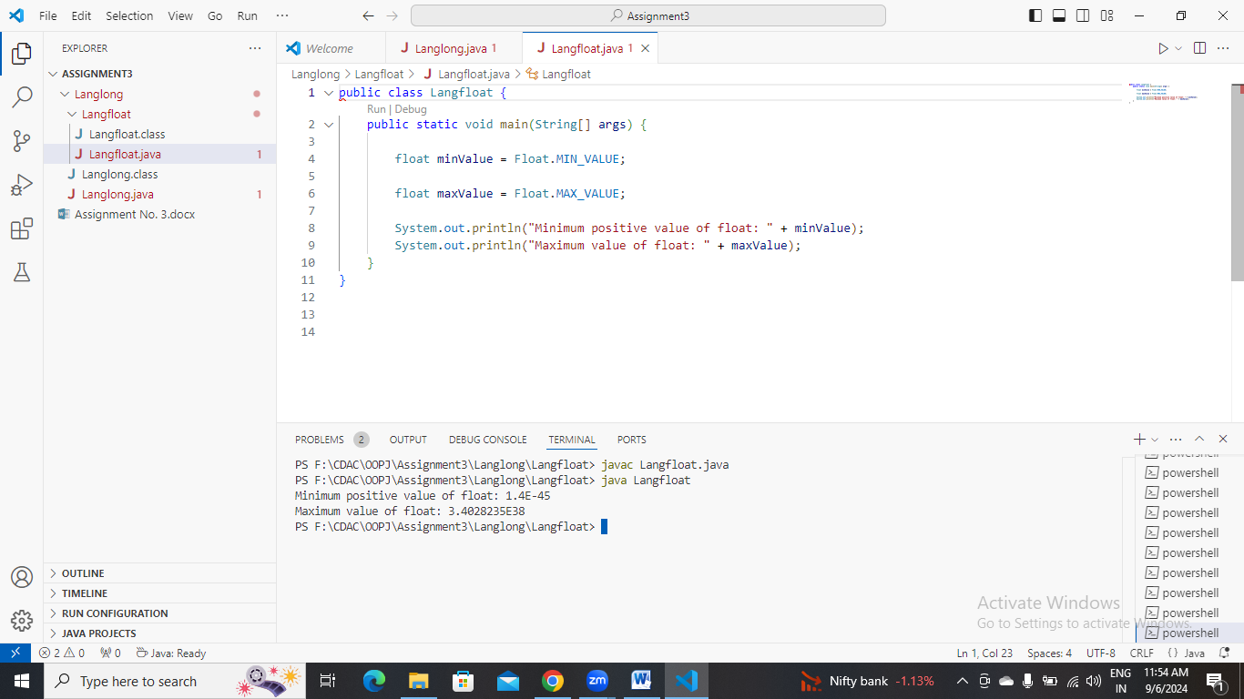

**d.** Declare a method-local variable number of type float with some value and convert it to a String using the toString method. (Hint: Use Float.toString(float)).

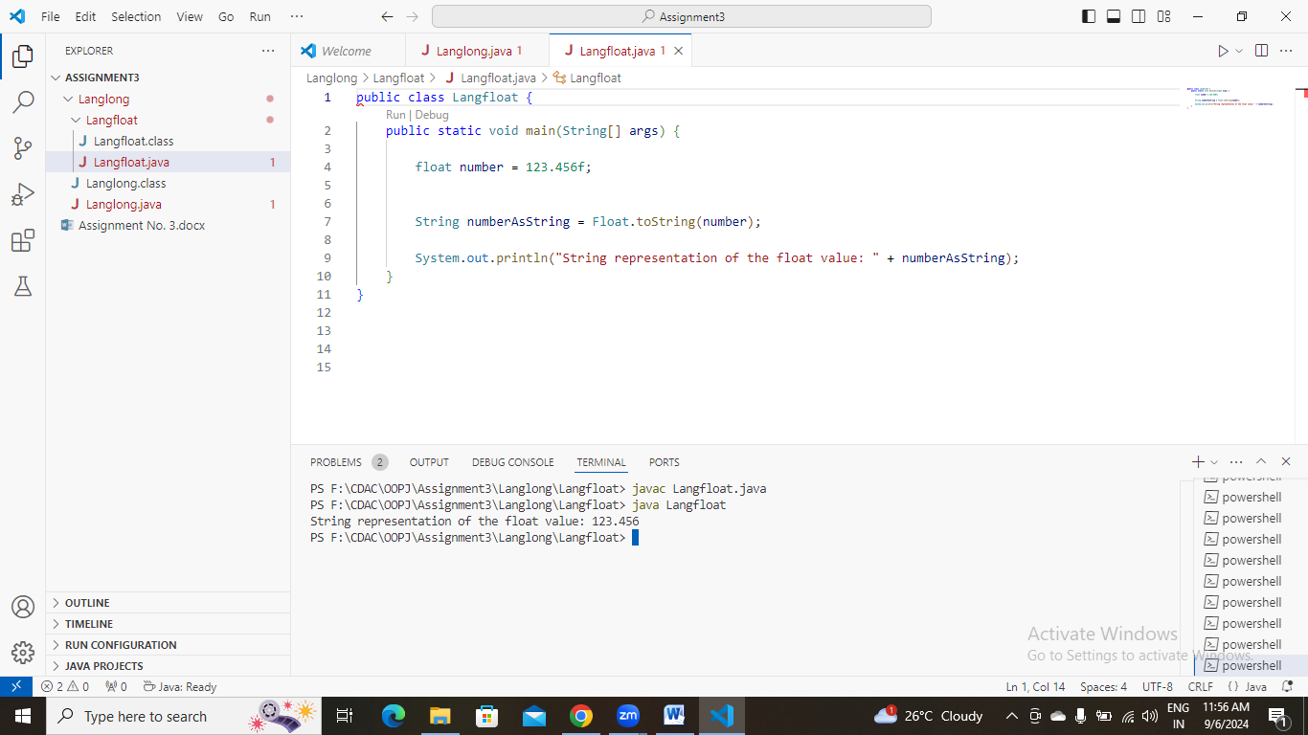

**e.** Declare a method-local variable strNumber of type String with some value and convert it to a float value using the parseFloat method. (Hint: Use Float.parseFloat(String)).

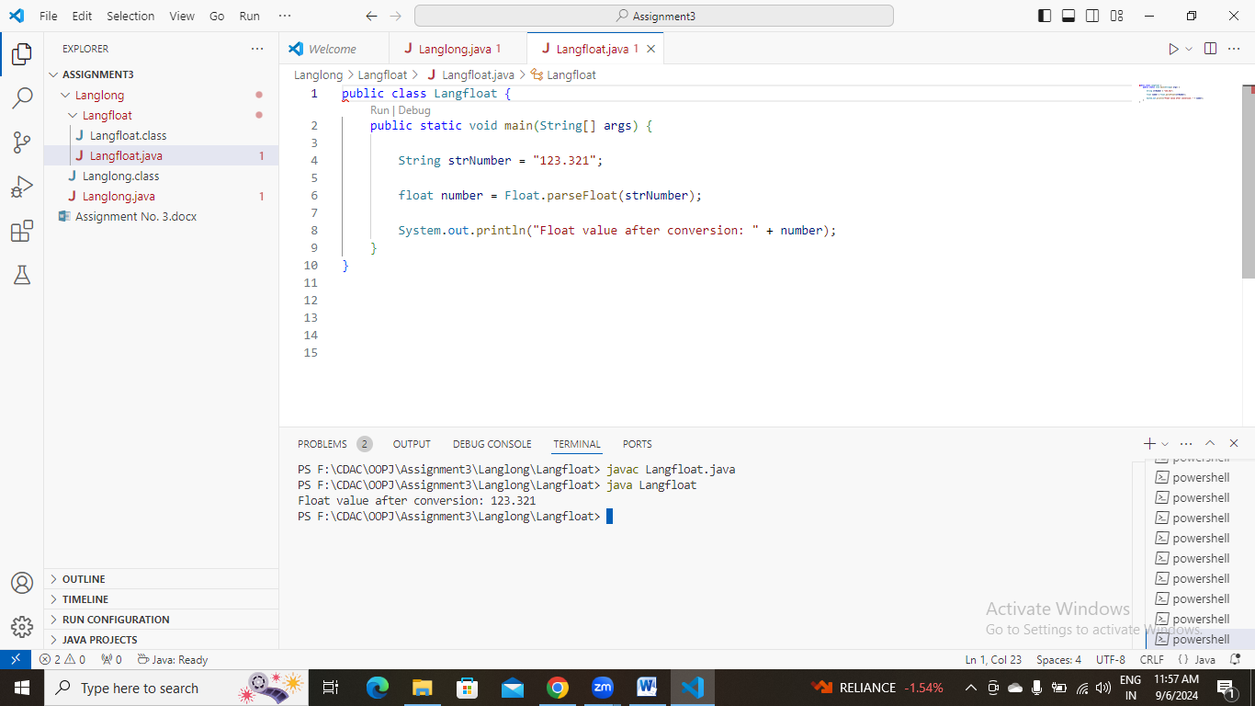

**f.** Declare a method-local variable strNumber of type String with the value "Ab12Cd3" and attempt to convert it to a float value. (Hint: parseFloat method will throw a NumberFormatException).

**g.** Declare a method-local variable number of type float with some value and convert it to the corresponding wrapper class using Float.valueOf(). (Hint: Use Float.valueOf(float)).

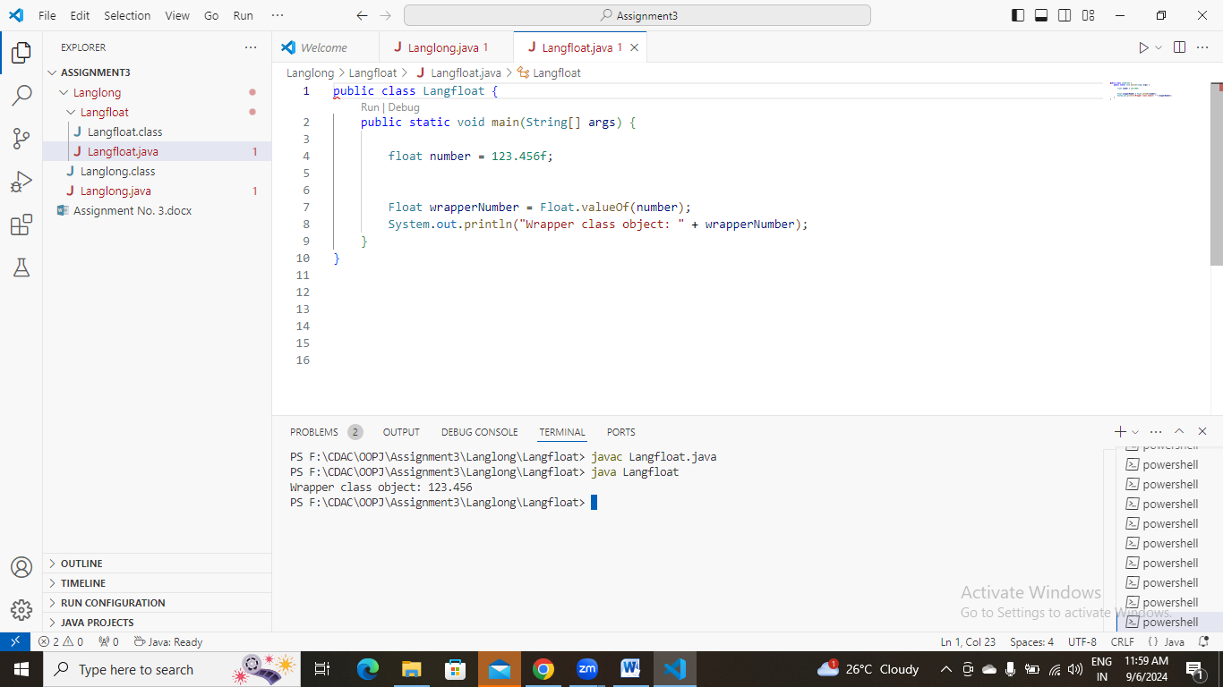

**h.** Declare a method-local variable strNumber of type String with some float value and convert it to the corresponding wrapper class using Float.valueOf(). (Hint: Use Float.valueOf(String)).

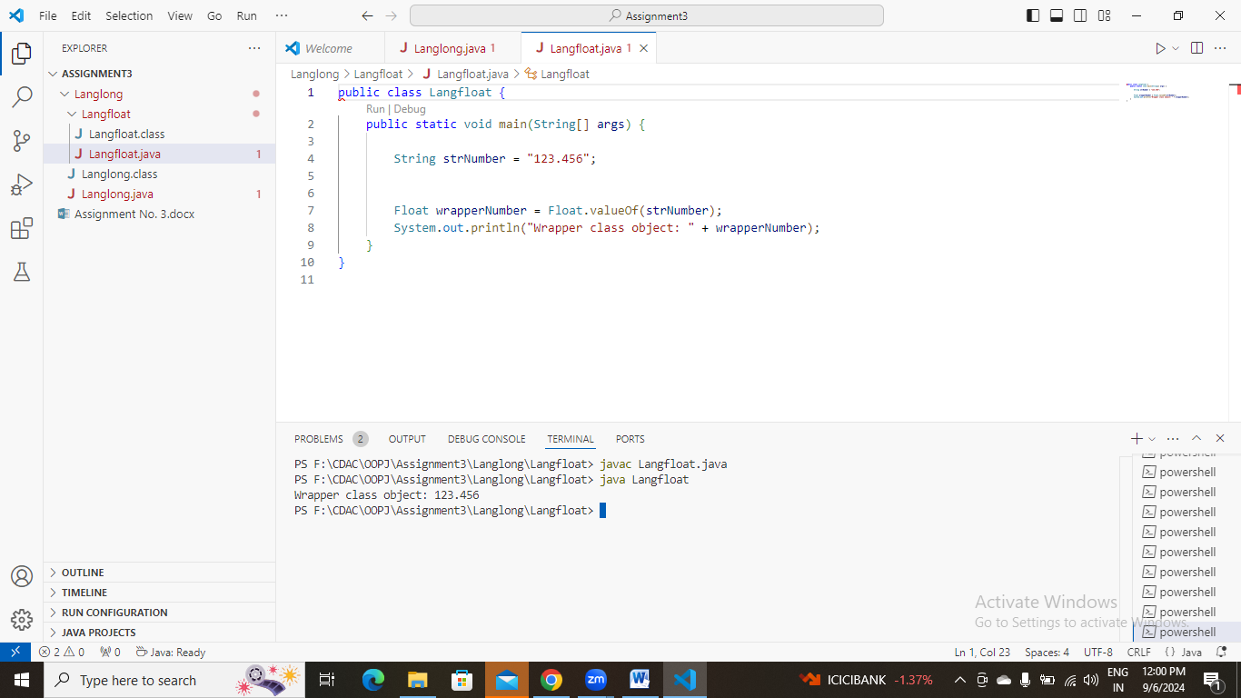

1. Declare two float variables with values 112.3 and 984.5, and add them using a method from the Float class. (Hint: Use Float.sum(float, float)).
2. 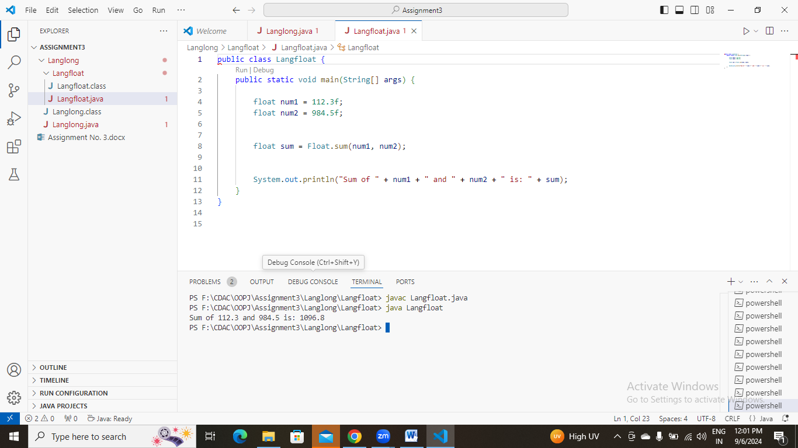

**j.** Declare two float variables with values 112.2 and 556.6, and find the minimum and maximum values using the Float class. (Hint: Use Float.min(float, float) and Float.max(float, float)).

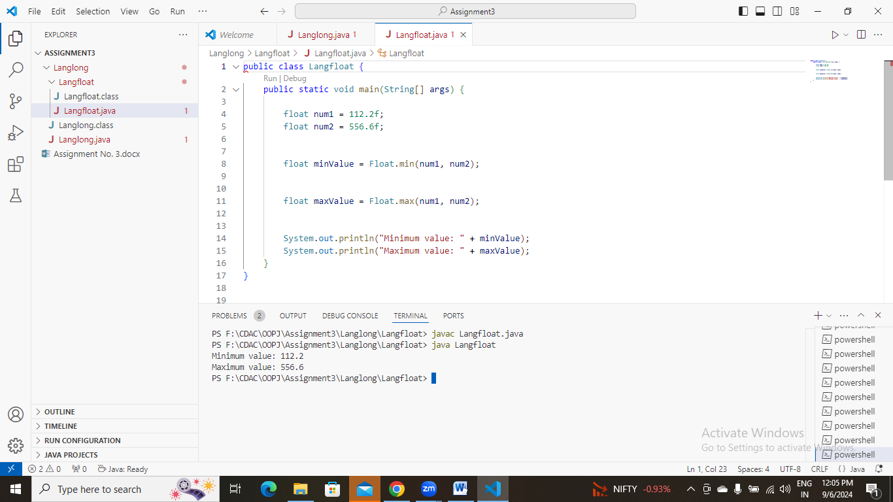

**k.** Declare a float variable with the value -25.0f. Find the square root of this value. (Hint: Use Math.sqrt() method).

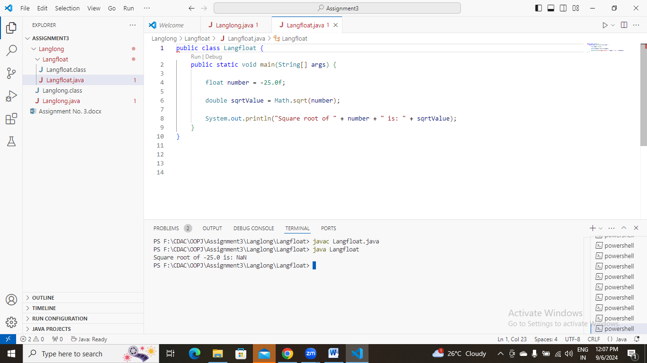

**l.** Declare two float variables with the same value, 0.0f, and divide them. (Hint: Observe the result and any special floating-point behavior).

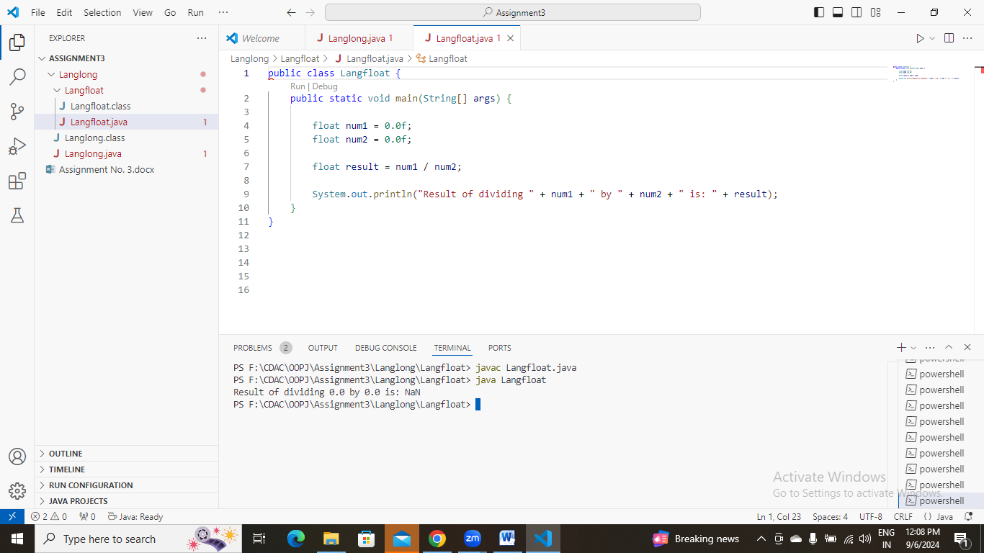

**m.** Experiment with converting a float value into other primitive types or vice versa and observe the results.

#### ****7. Working with**** java.lang.Double

**a.** Explore the [Java API documentation for java.lang.Double](https://docs.oracle.com/javase/8/docs/api/java/lang/Double.html) and observe its modifiers and super types.

**b.** Write a program to test how many bytes are used to represent a double value using the BYTES field. (Hint: Use Double.BYTES).

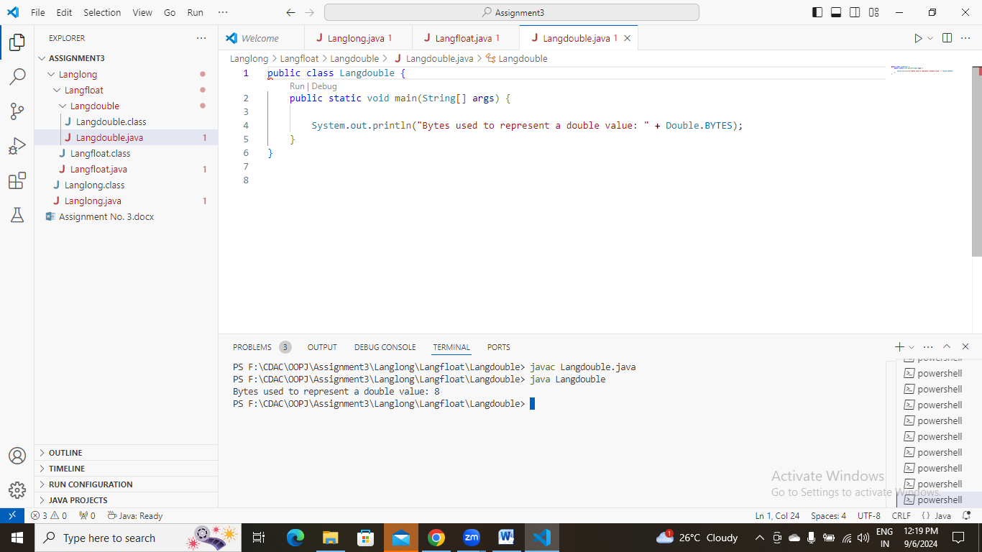

**c.** Write a program to find the minimum and maximum values of double using the MIN_VALUE and MAX_VALUE fields. (Hint: Use Double.MIN_VALUE and Double.MAX_VALUE).

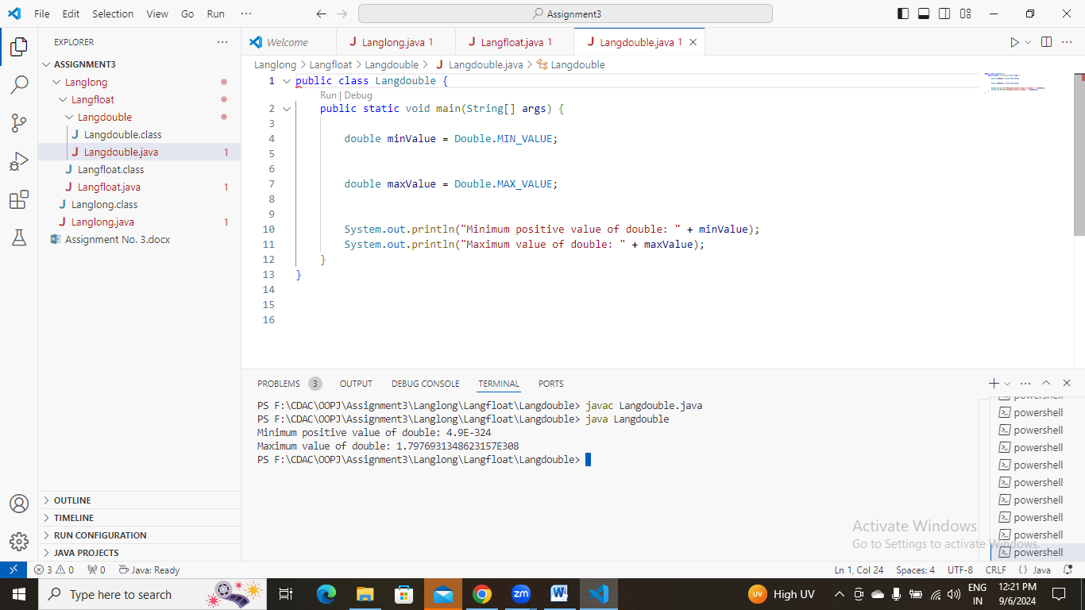

**d.** Declare a method-local variable number of type double with some value and convert it to a String using the toString method. (Hint: Use Double.toString(double)).

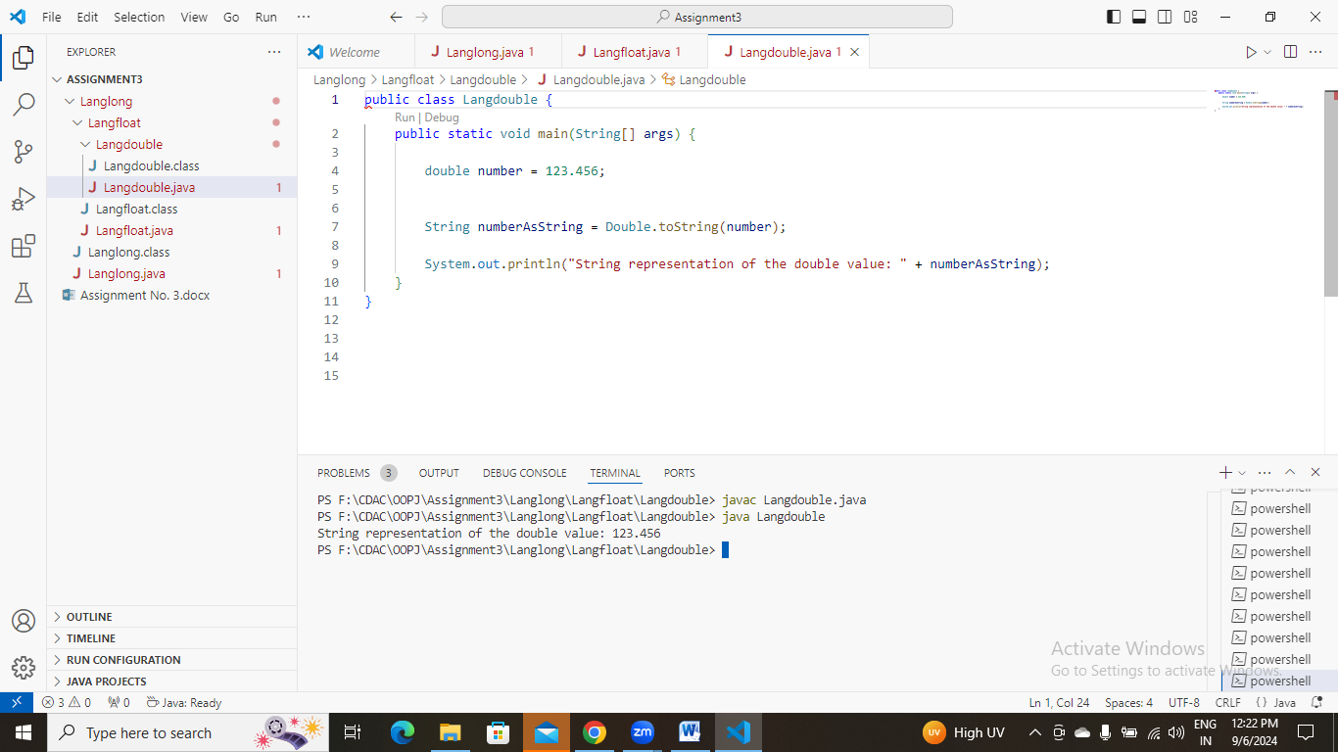

**e.** Declare a method-local variable strNumber of type String with some value and convert it to a double value using the parseDouble method. (Hint: Use Double.parseDouble(String)).

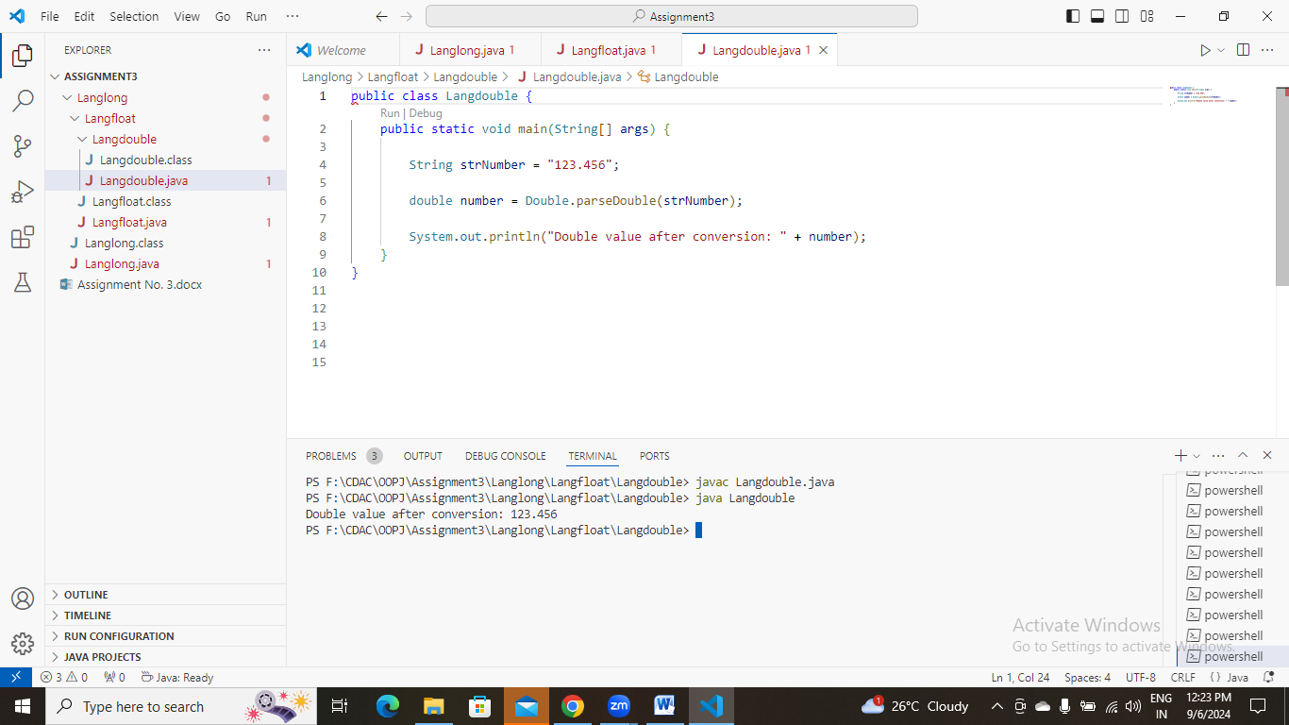

**f.** Declare a method-local variable strNumber of type String with the value "Ab12Cd3" and attempt to convert it to a double value. (Hint: parseDouble method will throw a NumberFormatException).

**g.** Declare a method-local variable number of type double with some value and convert it to the corresponding wrapper class using Double.valueOf(). (Hint: Use Double.valueOf(double)).

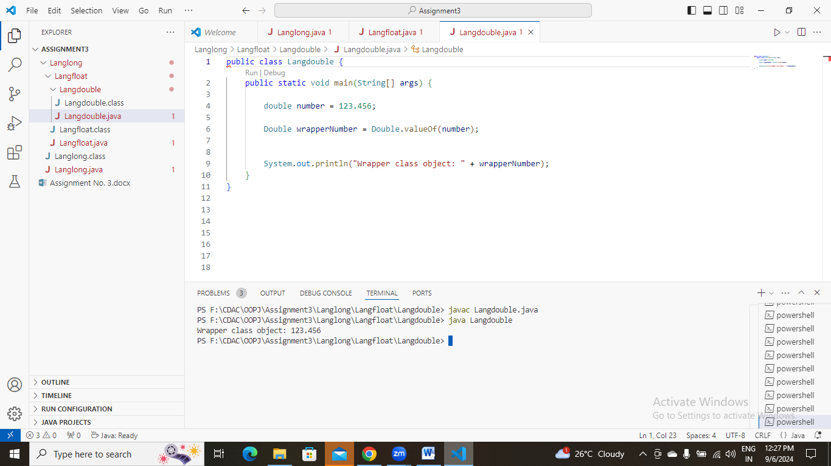

**h.** Declare a method-local variable strNumber of type String with some double value and convert it to the corresponding wrapper class using Double.valueOf(). (Hint: Use Double.valueOf(String)).

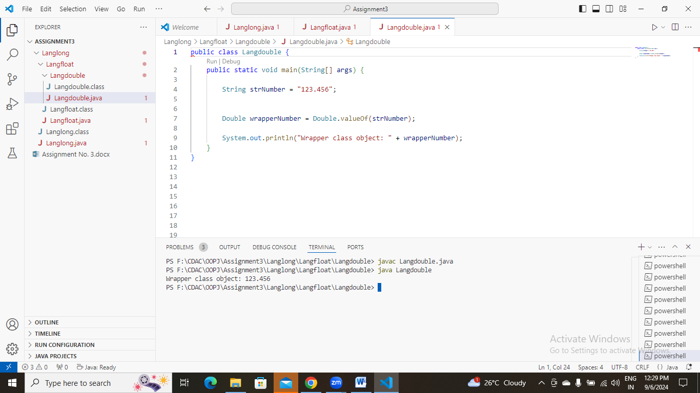

1. Declare two double variables with values 112.3 and 984.5, and add them using a method from the Double class. (Hint: Use Double.sum(double, double)).
2. 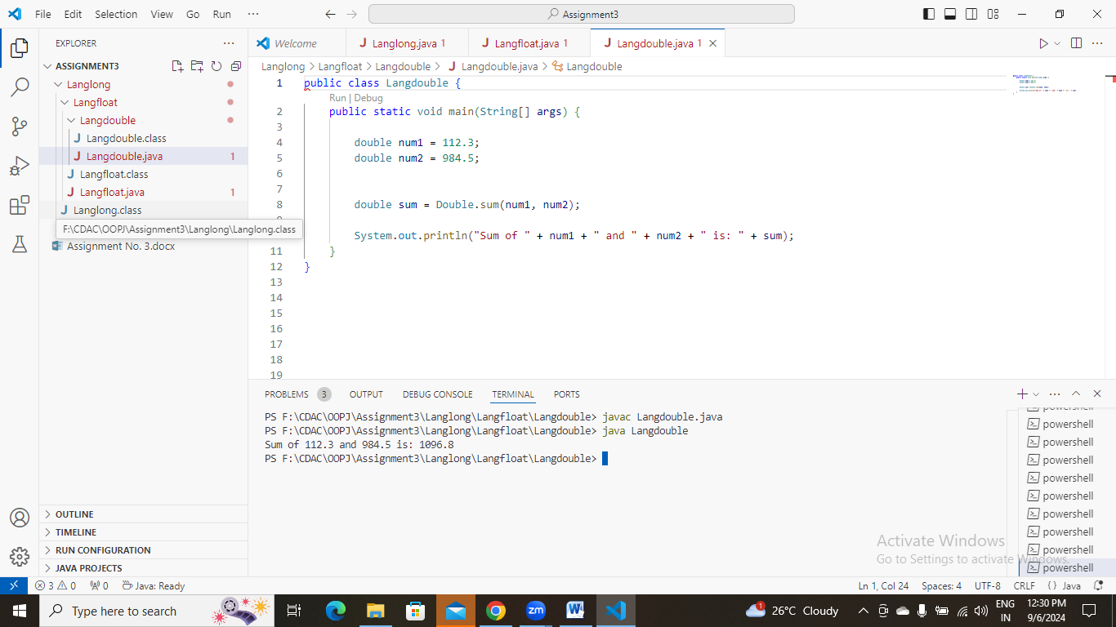

**j.** Declare two double variables with values 112.2 and 556.6, and find the minimum and maximum values using the Double class. (Hint: Use Double.min(double, double) and Double.max(double, double)).

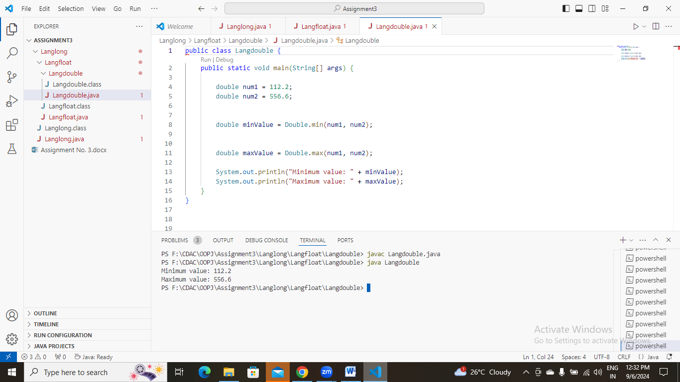

**k.** Declare a double variable with the value -25.0. Find the square root of this value. (Hint: Use Math.sqrt() method).

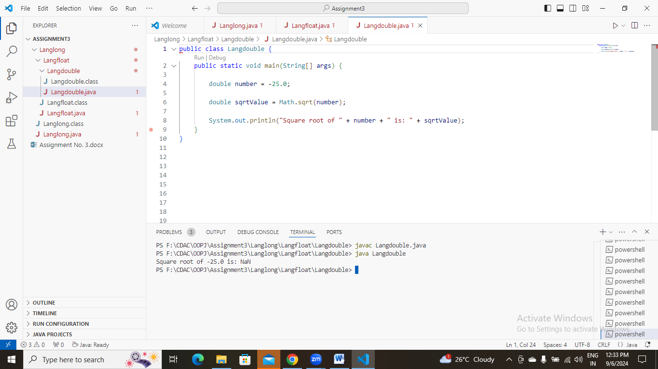

**l.** Declare two double variables with the same value, 0.0, and divide them. (Hint: Observe the result and any special floating-point behavior).

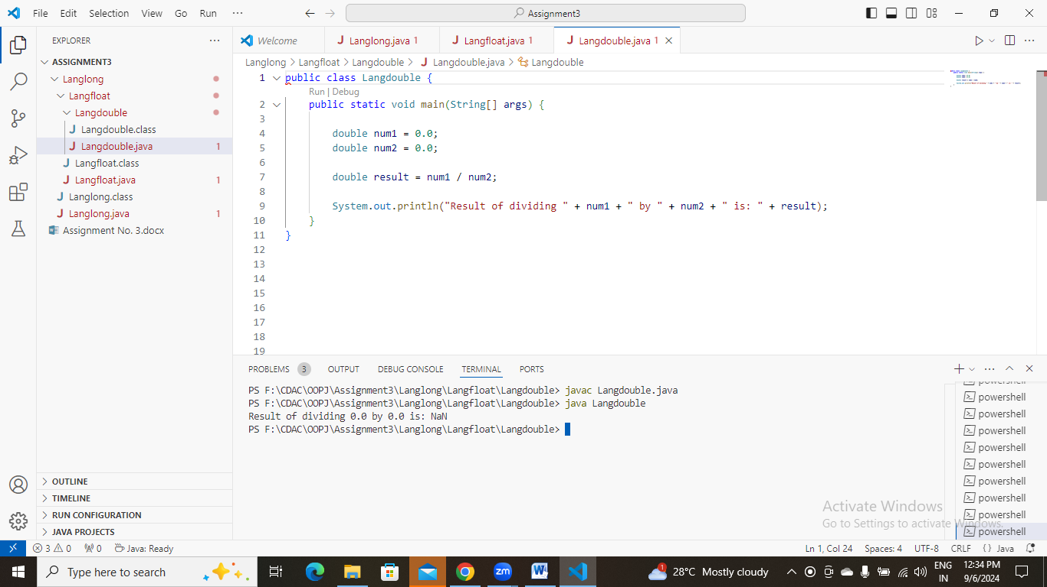

**m.** Experiment with converting a double value into other primitive types or vice versa and observe the results.

#### ****8. Conversion between Primitive Types and Strings****

Initialize a variable of each primitive type with a user-defined value and convert it into String:

* + First, use the toString method of the corresponding wrapper class. (e.g., Integer.toString()).
  + Then, use the valueOf method of the String class. (e.g., String.valueOf()).

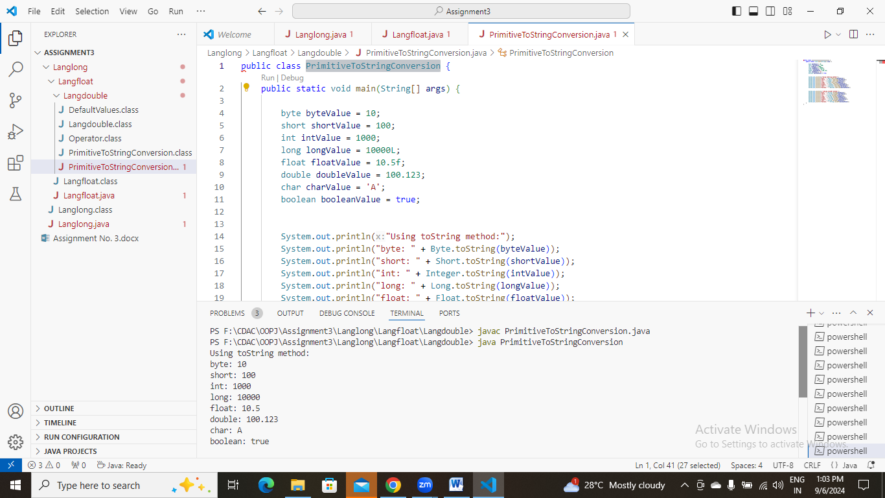

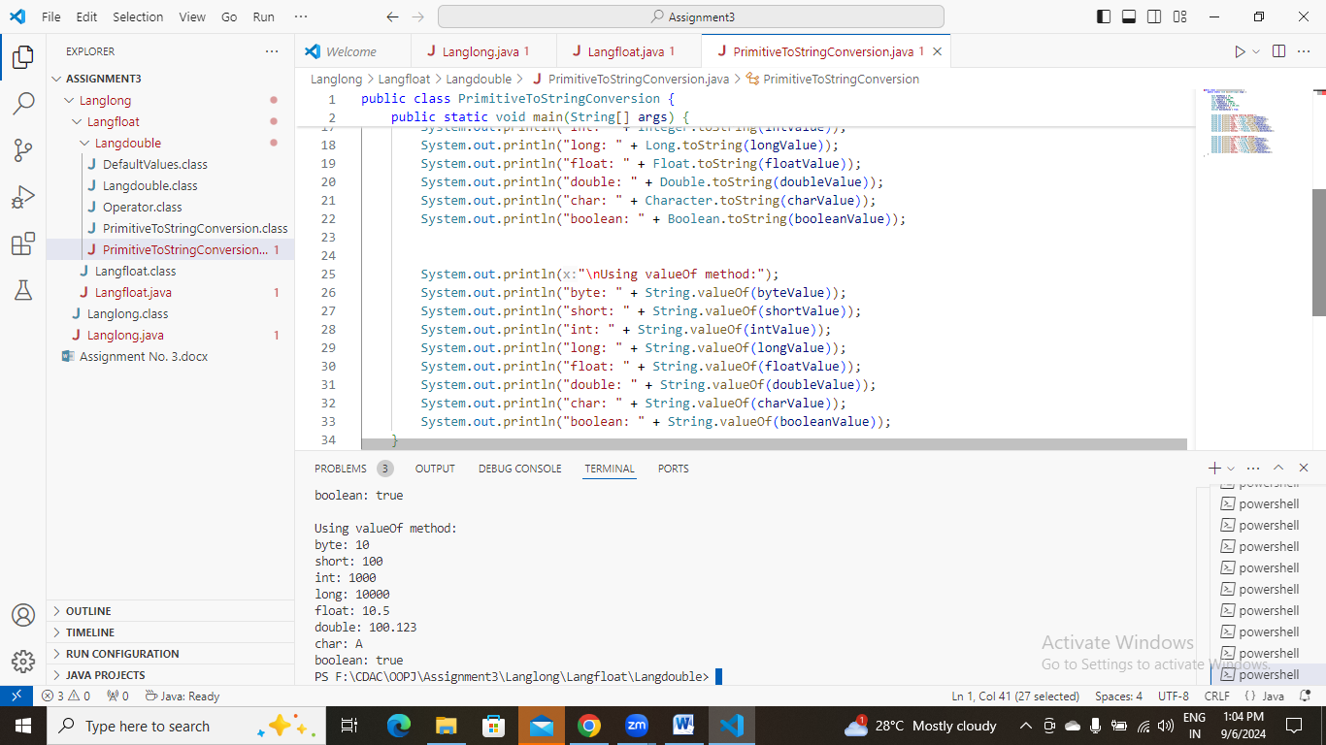

#### ****9. Default Values of Primitive Types****

Declare variables of each primitive type as fields of a class and check their default values. (Note: Default values depend on whether the variables are instance variables or static variables).

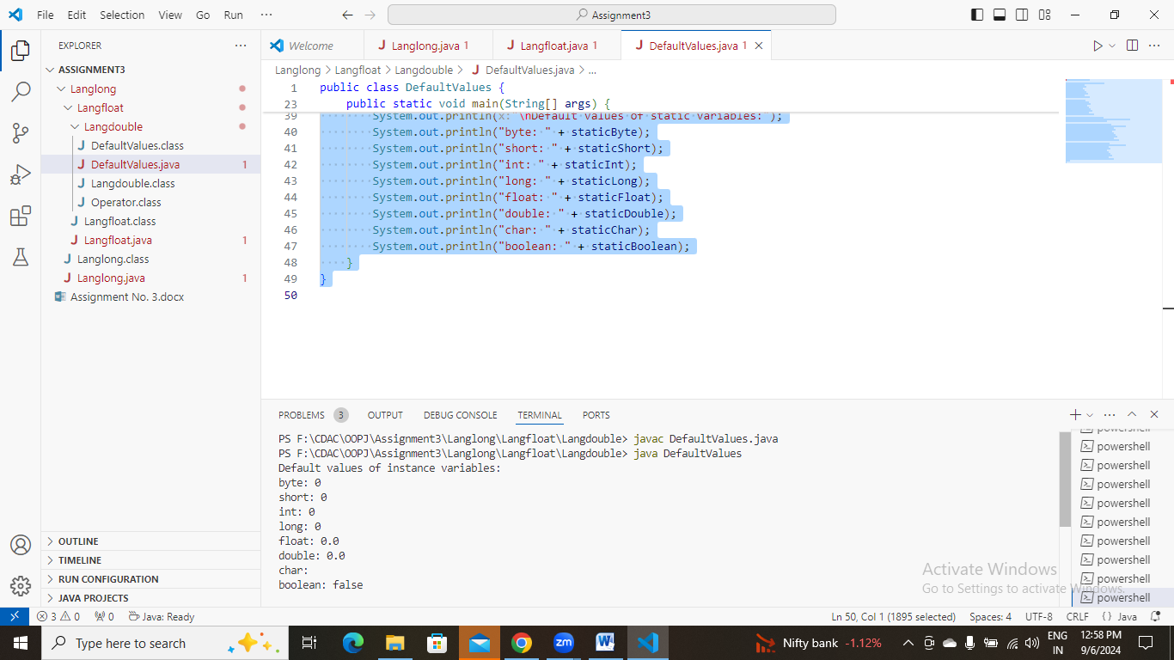

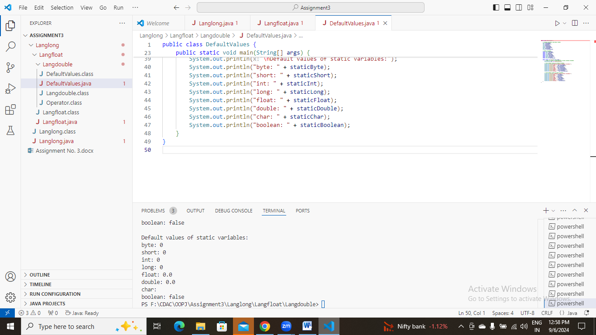

public class DefaultValues {

    byte instanceByte;

    short instanceShort;

    int instanceInt;

    long instanceLong;

    float instanceFloat;

    double instanceDouble;

    char instanceChar;

    boolean instanceBoolean;

    static byte staticByte;

    static short staticShort;

    static int staticInt;

    static long staticLong;

    static float staticFloat;

    static double staticDouble;

    static char staticChar;

    static boolean staticBoolean;

    public static void main(String[] args) {

        DefaultValues obj = new DefaultValues();

        System.out.println("Default values of instance variables:");

        System.out.println("byte: " + obj.instanceByte);

        System.out.println("short: " + obj.instanceShort);

        System.out.println("int: " + obj.instanceInt);

        System.out.println("long: " + obj.instanceLong);

        System.out.println("float: " + obj.instanceFloat);

        System.out.println("double: " + obj.instanceDouble);

        System.out.println("char: " + obj.instanceChar);

        System.out.println("boolean: " + obj.instanceBoolean);

        System.out.println("\nDefault values of static variables:");

        System.out.println("byte: " + staticByte);

        System.out.println("short: " + staticShort);

        System.out.println("int: " + staticInt);

        System.out.println("long: " + staticLong);

        System.out.println("float: " + staticFloat);

        System.out.println("double: " + staticDouble);

        System.out.println("char: " + staticChar);

        System.out.println("boolean: " + staticBoolean);

    }

}

#### ****10. Arithmetic Operations with Command Line Input****

Write a program that accepts two integers and an arithmetic operator (+, -, *, /) from the command line. Perform the specified arithmetic operation based on the operator provided. (Hint: Use switch-case for operations).

public class Operator {

    public static void main(String[] args) {

        if (args.length != 3) {

            System.out.println("Usage: java Calculator <number1> <operator> <number2>");

            return;

        }

        int num1 = Integer.parseInt(args[0]);

        String operator = args[1];

        int num2 = Integer.parseInt(args[2]);

        int result;

        switch (operator) {

            case "+":

                result = num1 + num2;

                break;

            case "-":

                result = num1 - num2;

                break;

            case "*":

                result = num1 * num2;

                break;

            case "/":

                if (num2 == 0) {

                    System.out.println("Error: Division by zero");

                    return;

                }

                result = num1 / num2;

                break;

            default:

                System.out.println("Error: Invalid operator. Use +, -, *, or /.");

                return;

        }

        System.out.println("Result: " + result);

    }

}